Uses of the Buffalo for Plains Indians
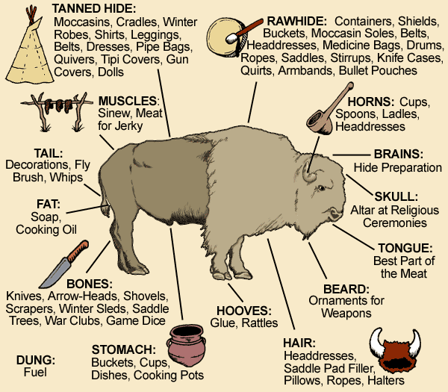
- The buffalo was the most important natural resource of the Plains Indians. Why do think it was so important?

- There were several ways to hunt the buffalo. One way was for Indians on horseback to ride into the herd on horseback and use bows and arrows to kill the buffalo. Another way was for a large group of Indians on horseback to chase the buffalo off a cliff. An unusual way some Indians hunted the buffalo was to sneak up on the buffalo with wolf skins covering their bodies, then killing them with bows and arrows. As soon as the hunt was over, the women and children would join the warriors to cut up the buffalo to bring back to camp. At this time it was considered a real treat to eat the heart, liver, kidneys, and brain while they were still warm.
Which way to hunt do you think might be most successful?

- It was only when the white man started moving west that the slaughter, unnecessary killing, of the buffalo occurred. Thousands of buffalo were killed for sport or to clear the land for the railroad. These animals' bodies were just left on the prairie to rot.
How do think the Plains Indians were affected by the decrease in population of the buffalo?

Uses of the Buffalo for Plains Indians
- The buffalo was the most important natural resource of the Plains Indians. Why do think it was so important?

- There were several ways to hunt the buffalo. One way was for Indians on horseback to ride into the herd on horseback and use bows and arrows to kill the buffalo. Another way was for a large group of Indians on horseback to chase the buffalo off a cliff. An unusual way some Indians hunted the buffalo was to sneak up on the buffalo with wolf skins covering their bodies, then killing them with bows and arrows. As soon as the hunt was over, the women and children would join the warriors to cut up the buffalo to bring back to camp. At this time it was considered a real treat to eat the heart, liver, kidneys, and brain while they were still warm.
Which way to hunt do you think might be most successful?

- It was only when the white man started moving west that the slaughter, unnecessary killing, of the buffalo occurred. Thousands of buffalo were killed for sport or to clear the land for the railroad. These animals' bodies were just left on the prairie to rot.
How do think the Plains Indians were affected by the decrease in population of the buffalo?

