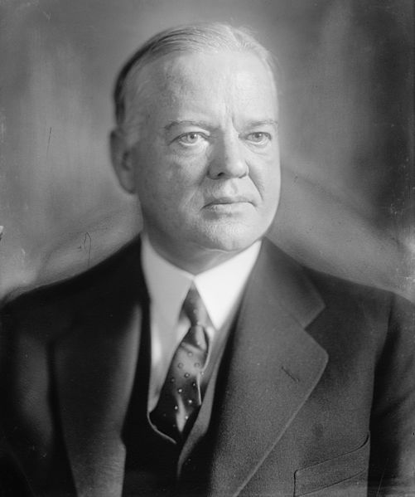
The Government's Response: Hoover
President Herbert Hoover resisted calls for government intervention on behalf of individuals. He reiterated his belief that if left alone the economy would right itself and argued that direct government assistance to individuals would weaken the moral fiber of the American people. Hoover further believed that during hard times the government should adopt austerity measures, that is, cut spending even further. Forced by Congress to intervene, Hoover did so reluctantly, concerned about both unbalancing the federal budget, and, even more importantly, violating his laissez-faire principles (the economy functions without government interference). Hoover's efforts consisted of spending to stabilize the business community, believing that returning prosperity would eventually "trickle down" to the poor majority.
While not believing in charity by the government, Hoover did try and help the economic mess that began during his administration. He gave much of his money to charity and encouraged Americans to do the same. He broke with Republicans and did away with the taxes that had been placed on citizens during the Coolidge administration. He thought that would allow for more income being spent to help the economy rebound. He spent $500 million a year on public works and government programs to build or improve government properties. The most famous was the Hoover (Boulder) Dam. Congress established the Reconstruction Finance Corporation (continued by FDR) which created an agency to help banks, railroads, and other key businesses to stay in business thus helping the economy. All of these things could not stem the tide of the economic collapse. Hoover believed in a balanced budget and not pumping government money into the economy. He believed in "rugged individualism" and relied on the individual, the churches and private charities, and the local and state governments to handle most of the economic help that was needed.
The poor majority proved unwilling to wait. Branded by his many detractors as cold and uncaring, Hoover was easily defeated in the presidential election of 1932 by Democrat Franklin D. Roosevelt.

The Government's Response: Roosevelt
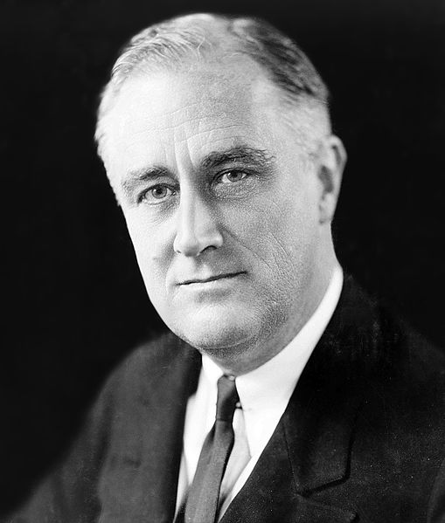
Roosevelt remained vague on the campaign trail, promising only that under his presidency government would act decisively to end the Depression. Once in office, FDR said yes to almost every plan put forward by advisors, and the Congress said yes to almost every program proposed by the president. In the fast paced first few months of his administration, Congress passed scores of new legislation at the president's request. Historians tend to categorize these efforts as either measures for "relief" (short-term programs designed to alleviate immediate suffering), "recovery" (long-term programs to strengthen the economy back to its pre-crash level), or, "reform" (permanent structures meant to prevent future depressions). Another way of understanding FDR's Depression-fighting efforts is to analyze the politics of the New Deal. Generally speaking, the overall aim of the New Deal was essentially conservative. The New Deal sought to save capitalism and the fundamental institutions of American society from the disaster of the Great Depression. Within that framework, however, significant differences between New Deal programs existed. The "first" New Deal (1933-35) tended toward a continuation of "trickle down" policies, albeit better funded and executed more creatively.
"Second" New Deal (1935-40s)
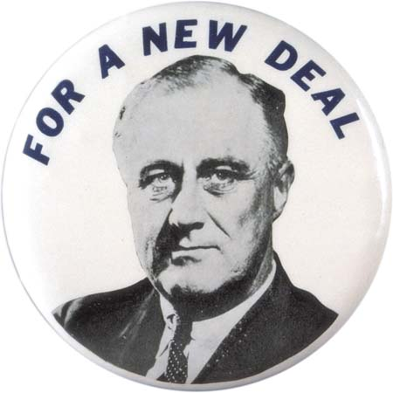
The "second" New Deal attempted to end the Depression by spending at the bottom of the economy where government funds attempted to turn non-consumers into consumers again. Many of the programs lasted only until World War II while others became permanent fixtures in American life. Here are three to illustrate the central thrust of the second New Deal. The Works Progress Administration was a huge federal jobs program that sought to hire unemployed breadwinners for the purpose strengthening their family's well being as well as boosting consumer demand. The jobs varied but consisted of mainly of construction of public roads, buildings and parks. Over the course of its life (1935-43) over eight million Americans worked on WPA projects.
The 1935 Social Security Act set up a modest worker-funded but federally guaranteed pension system. Social Security acted as a safety net for older workers, promoted increased consumer demand, and earned a place as a fixture on the American political and social landscape.
Finally, another significant component of the "second" New Deal was the National Labor Relations Act of 1935. This law attempted to prevent employers' use of intimidation and coercion in breaking up unions. It set up the National Labor Relations Board to guarantee the right of collective bargaining for American workers. The results were immediately discernable: the formation of the Congress of Industrial Organizations whose auto worker and coal miner units soon saw their wages increase significantly. Again, higher wages among the masses of the working class is an example of the "second" New Deal's attempt to restore the economy from the bottom up.

Assessing the legacy of the New Deal
World War II ended both the temporary New Deal programs and the Depression they were attempting to cure. Keep in mind that many facets of the New Deal—Social Security, the Federal Deposit Insurance Corporation and the Securities and Exchange Commission to name only three—have remained features of American life from the 1930s until the present. War ended the Depression simply because of increased government spending; an intensified version of what Roosevelt was already doing with the WPA and similar programs. Responding to the external threats posed by the Axis Powers (Germany, Japan and Italy) Roosevelt and the Congress threw fiscal caution to the wind and spent what was necessary to win the war. In so doing, they also achieved pre-Depression levels of employment and prosperity.
What then is the legacy of the New Deal as a whole? Would it have ended the Depression? The best answer to that is that it went a long way toward alleviating the worst suffering of the Depression while still being captive to the conventional thinking (political, fiscal, racial) of the day. We cannot answer that question of whether it could have ended the Depression based on historical facts. World War II interrupted the process.
What are the other long-term consequences of the Depression and New Deal? The rise of the "Roosevelt Coalition" of farmers, union members, working class people, Northern blacks and liberals made the Democratic Party the nation's dominant party for almost sixty years. Further, the political consensus that developed after World War II held that never again should the government allow another depression to take hold. Thus, there followed an unprecedented level of federal economic intervention. This was a huge expansion in the role, size and power of government in American social and economic life.

http://iws.collin.edu/kwilkison/Online1302home/20th%20Century/DepressionNewDeal.html

