Name _____________________________________
Fall of Napoleon Activity

1: The Continental System
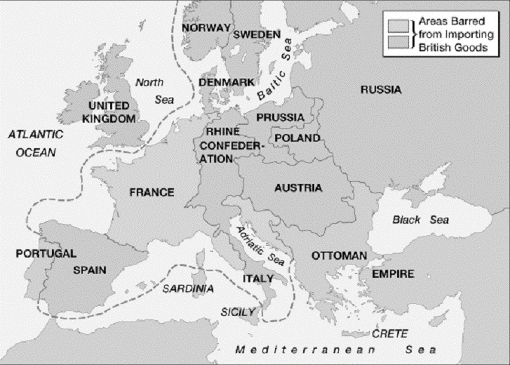
- What was the Continental System?

- How was it intended to impact Great Britain?

- What were the issues/problems with the Continental System being successful? (list all of them)

- How did Britain respond to the Continental System?

- The map shows the areas impacted by the Contiental System.
- Using colored pencils, color: Portugal, France, and the Ottoman Empire one color. Also, color the top box of the key this color.
- Using colored penicils, color: Spain Rhine Confederation, Italy, Denmark, Norway, Sweden, Prussia, Poland, Austria, and Russia another color. Also, color the bottom box of the key this color.
- What is the dotted line representing?

2: Invasion of Russia
- Why did Napoleon invade Russia?

- What was the scorched-earth policy?

Why do you think the Russians used this method of defense instead of fighting?

- Describe what occurred in Moscow.

- Why do you think Napoleon decided to return to France with his army and give up on Russia?

- Describe the French army’s retreat.

3: Napoleon’s Downfall
- Which nations allied together against Napoleon to defeat him?

- Why do you suppose Napoleon’s army was defeated?

- In the end, Napoleon was banished to ______________. Where was this island? (See the map above to see how close it was to France.)

4: The Hundred Days
- _____________________ became king of France after Napoleon was removed from power. How did the people of France feel about him?

Why?
- Napoleon escaped from exile and returned France. How was he greeted?

- Battle of Waterloo-

- After his defeat, he was exiled to _____________________ (in the South Atlantic).

5: Congress of Vienna
- What was the purpose of the Congress of Vienna?

- Who were the “great powers” who made the decisions?

- Explain in detail the 3 main goals at the Congress of Vienna.

6: Napoleon’s Legacy
- Create your own chart—list what you feel were the 3 most important positive and negative impacts he had on France.
Positive Impact | Negative Impact
1  2  3 | 1  2  3

- Do you think Napoleon should be remembered as a great leader or a not? Explain your answer.

