Name ____________________________________________
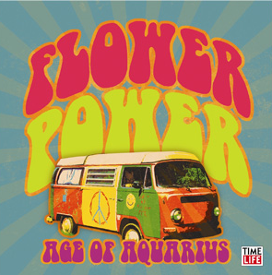
Counterculture
- Before you begin reading, what images come to mind when you hear the word “hippie?”

- Counterculture-

- What were some of the beliefs of the hippies?

- Describe the communes that hippies lived in.

- Describe the food and clothing of the hippies.

- What was the music of the counterculture like?

- What percent of the youth population was part of the counterculture?

- Once the hippie-commune lifestyle ended, what difficulties do you thing hippies might have had joining back into mainstream culture?

- How different do you think American society today would be if the counterculture had not occurred?

Music of the Counterculture
 | What is the song about? | Who does this song speak on behalf of? | What does it reveal about the counterculture and/or the Vietnam War?
- “Ohio” by Crosby Stills Nash Young

- “War” by Edwin Starr

- “Fortunate Son” by Creedence Clearwater Revival

- Jimi Hendrix “Star Spangled Banner” | ------------leave blank-------------- | ------leave blank-------

Counterculture Caricature:
  - See—point to eyes
  - Hear—point to ears
  - Say—point to mouth
  - Feel—point to heart
  - Do—point to hands
  - Walk/journey—point to feet
Draw a caricature of either: a hippie or a Vietnam soldier
Make sure you:
- Color picture
- Write a description of what they might be sensing during this time. (Each of the 6 things in the box to the right must be included.)
- Make a reference to at least ONE historic event during this time (such as: Kent State Massacre, Tet Offensive, My Lai Massacre, Vietnamization,…)

