The End of the Cold War
The Soviet Union
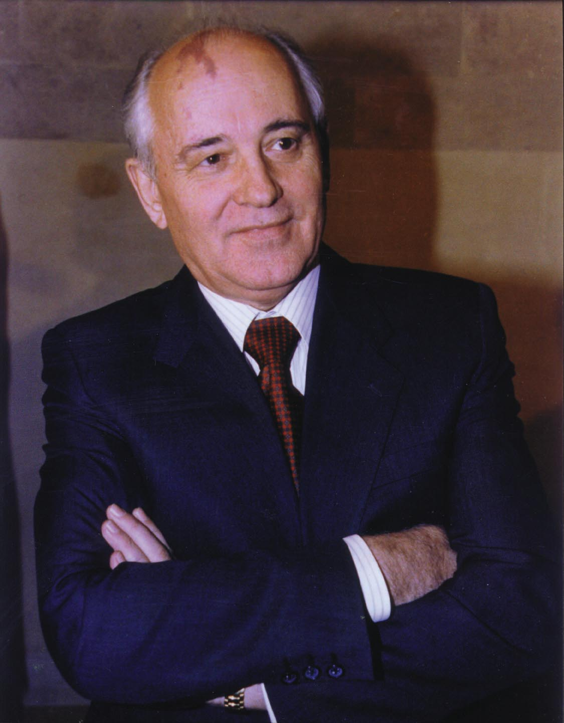
When Mikhail Gorbachev became the leader of the Communist Party of the Soviet Union in 1985, no one predicted the revolution he would bring. At 54, he was the youngest Soviet leader since Stalin. Gorbachev was only a child during Stalin’s ruthless purge of independent-minded party members. Unlike other Soviet leaders, Gorbachev decided to pursue new ideas.
A dedicated reformer, Gorbachev introduced the policies of glasnost and perestroika to the USSR.
Glasnost, or openness, meant a greater willingness on the part of Soviet officials to allow western ideas and goods into the USSR. Glasnost brought remarkable changes. The government allowed churches to open. It released dissidents from prison and allowed the publication of books by previously banned authors. Reporters investigated problems and criticized officials.
Perestroika was an economic initiative that allowed limited market incentives to Soviet citizens. In 1986, he made changes to revive the Soviet economy. Local managers gained greater authority over their farms and factories, and people were allowed to open small private businesses. Gorbachev’s goal was not to throw out communism, but to make the economic system more efficient and productive.
Mikhail Gorbachev
Gorbachev hoped these changes would be enough to spark the sluggish Soviet economy. Freedom, however, is addictive.
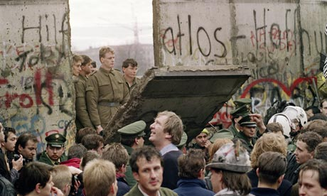
The unraveling of the Soviet Bloc began in Poland in June 1989. Despite previous Soviet military interventions in nations that were part of the Soviet Bloc, Polish voters elected a noncommunist opposition government to their legislature. The world watched with anxious eyes, expecting Soviet tanks to roll into Poland preventing the new government from taking power.
Like dominoes, Eastern European communist dictatorships fell one by one. On November 9, 1989, the East German government decided to open the Berlin Wall. Gorbachev, however, refused to intervene (he allowed the wall to be opened). By the fall of 1989, East and West Germans were tearing down the Berlin Wall with pickaxes. While many had taken axes to the Wall upon the collapse of Communism in Germany in 1989, the official destruction of the Berlin Wall did not begin until June, 1990.
Demands for freedom soon spread to the Soviet Union. The Baltic states of Estonia, Latvia, and Lithuania declared independence. By December of 1991, 14 non-Russian republics declared their independence from the Soviet Union. Muscled aside by Russian reformers who thought he was working too slowly toward democracy, Gorbachev himself lost power and resigned as Soviet president. After 74 years, the Soviet Union dissolved.
A loose federation known as the Commonwealth of Independent States (CIS) took the place of the Soviet Union. In February 1992, President George Bush and the new Russian President Boris Yeltsin issued a formal statement declaring an end to the Cold War that had plagued the two nations and divided the world since 1945. The statement marked the beginning of a new era of “friendship and partnership” between the two nations.
Americans were pleasantly shocked, but shocked nonetheless at the turn of events in the Soviet bloc. No serious discourse on any diplomatic levels in the USSR addressed the likelihood of a Soviet collapse. Republicans were quick to claim credit for winning the Cold War. They believed the military spending policies of the Reagan-Bush years forced the Soviets to the brink of economic collapse. Democrats argued that containment of communism was a bipartisan policy for 45 years begun by the Democrat Harry Truman.
Others pointed out that no one really won the Cold War. The United States spent trillions of dollars arming themselves for a direct confrontation with the Soviet Union that fortunately never came. Regardless, thousands of American lives were lost waging proxy wars in Korea and Vietnam.
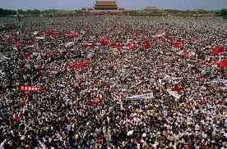
Most Americans found it difficult to get used to the idea of no Cold War. Now the enemy was beaten, but the world remained unsafe. In many ways, facing one superpower was simpler than challenging dozens of rogue states and renegade groups sponsoring global terrorism. Americans hoped against hope that the new world order of the 1990s would be marked with the security and prosperity to which they had become accustomed.

China
Even before perestroika unfolded in the Soviet Union, economic reform had begun in China. Early in the 1980s, the Chinese Communist government loosened it grip on business and eliminated some price controls. Students in China began to demand freedom of speech and a greater voice in the government.
In April 1989, university students in China held marches that quickly grew into large demonstrations in Beijing’s Tiananmen Square and on the streets of other cities. In Tiananmen Square, Chinese students constructed a version of the Statue of Liberty to symbolize their struggle for democracy.
Chinese premier, Li Peng, eventually ordered the military to crush the protesters. China’s armed forces stormed into Tiananmen Square, slaughtering unarmed students. The world’s democratic nations watched these events in horror on television. The collapse of the pro-democracy movement left the future in China uncertain. As one student leader said, “the government has won the battle here today. But they have lost the people’s hearts.”

http://www.ushistory.org/us/59e.asp

