Name _________________________________
Imperialism Primary and Secondary Sources Activity
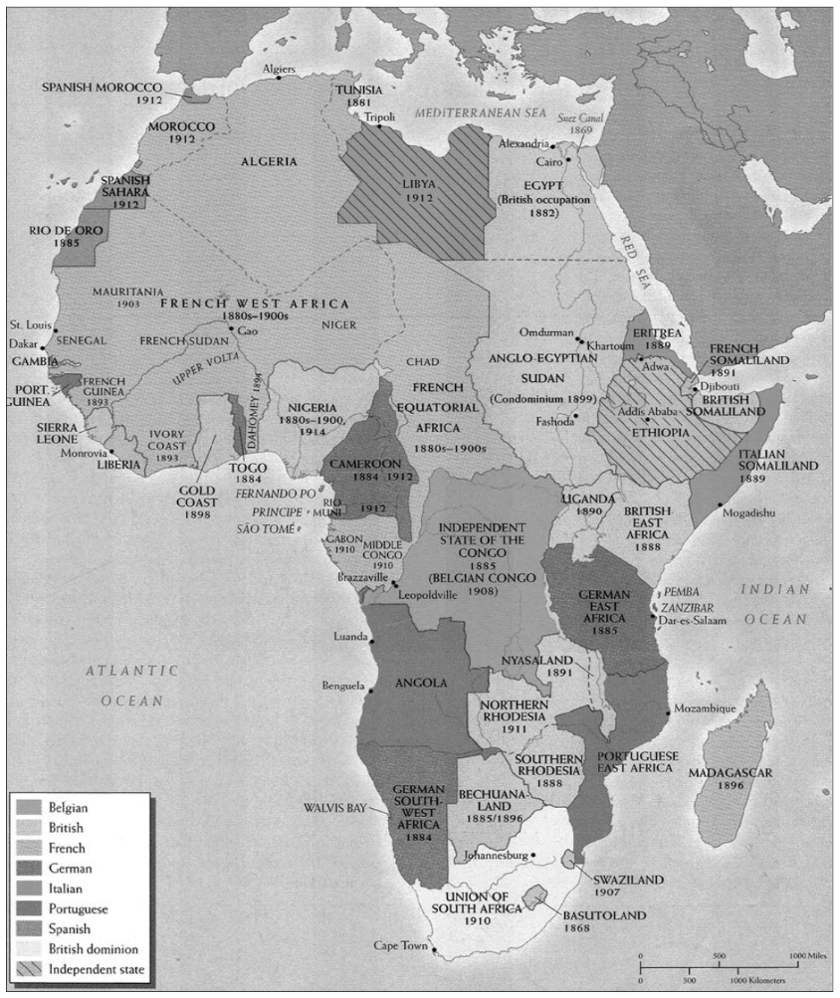
Source 1: Colonial Africa Map
- Examine the map of Africa from 1914. Which countries in held colonies in Africa?

- Which 2 countries held the most land in Africa?

- Circle the African nations that were able to successfully resist colonization.

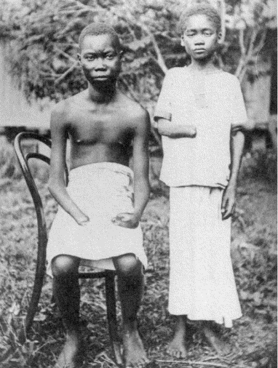
Source 2: Image from Congo
The imperialist powers saw Africa as a valuable source of raw materials that would fuel their growing economies. European businessmen made enormous profits by controlling the African trade in rubber, coffee, ivory, diamonds, palm oil, cotton, tea, and tobacco. Unfortunately, the drive for profit often led to incredible brutality and crimes against humanity. In the Congo, for example, which was under the rule of the Belgian King Leopold, local people were forced to collect rubber and other natural resources. Missionaries reported that African workers were killed for failing to meet their quotas. Belgian agents collected amputated hands and sent them back to the king as proof that his strict policies were being enforced.
- Why do you think these children are missing their hands? Who injured them and why?

- Who do you think took this picture?

- For what audience was this picture intended? Why do you think so?

Source 3: “White Man’s Burden” by Rudyard Kipling, 1899
Some westerners felt that it was their responsibility to help “civilize” the “savage” inhabitants of colonial lands in order to make them more “modern” and European. The English writer Rudyard Kipling, for example, displayed such an attitude in his 1899 poem entitled “The White Man’s Burden,” the first stanza of which is printed to the right.
Take up the White Man’s burden—
Send forth the best ye breed—
Go send your sons to exile
To serve your captives' need
To wait in heavy harness
On fluttered folk and wild—
Your new-caught, sullen peoples,
Half devil and half child.
Take up the White Man’s burden
In patience to abide
To veil the threat of terror
And check the show of pride;
By open speech and simple
An hundred times made plain
To seek another’s profit
And work another’s gain.
Take up the White Man’s burden—
And reap his old reward:
The blame of those ye better
The hate of those ye guard—
The cry of hosts ye humour
(Ah slowly) to the light:
"Why brought ye us from bondage,
“Our loved Egyptian night?”
Take up the White Man’s burden-
Have done with childish days-
The lightly proffered laurel,
The easy, ungrudged praise.
Comes now, to search your manhood
Through all the thankless years,
Cold-edged with dear-bought wisdom,
The judgment of your peers!

- How does the poem promote imperialism?

- The poem is often referred to as the “anthem of imperialism”.
According to Kipling, what was the “White Man’s Burden”?

- Look at the advertisement below for Pears’ Soap. The advertisement claims that Pears’ soap is a potent factor in brightening the dark corners of the earth as civilization advances…
What do you think the phrase “dark corners of the earth” refers to? Why?

- How does the advertisement display Social Darwinism?
