Post-Classical Americas Overview
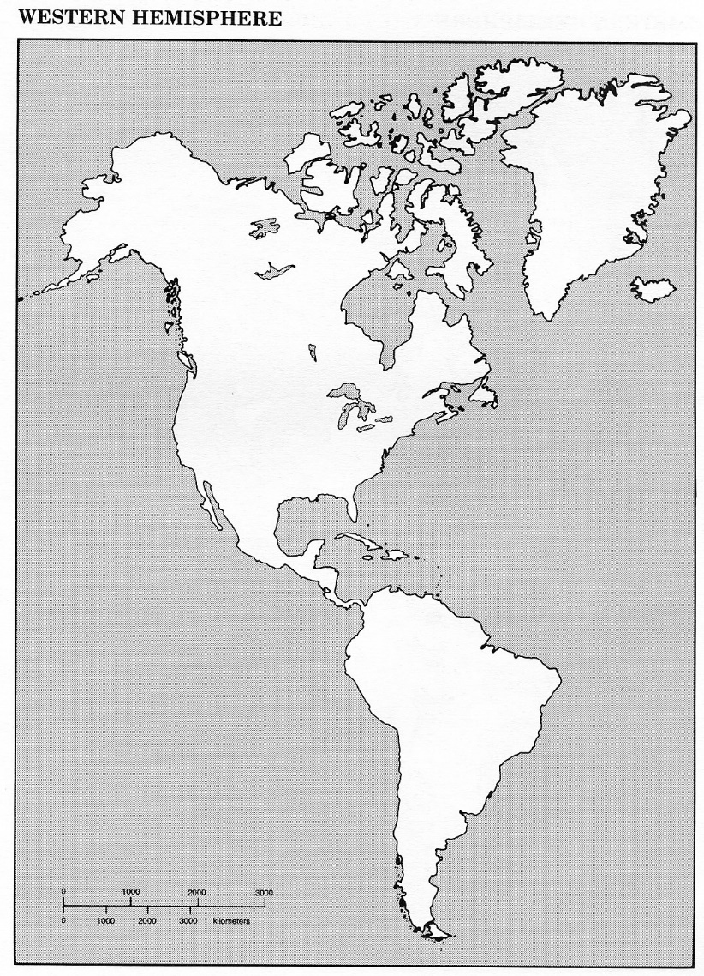
On the map, shade a different color each of the following civilizations: Cahokia, Anasazi, Mayan, Aztec, Inca.
Draw a picture to represent ONE key, overarching theme or idea for each civilization.
Cahokia
Anasazi
Maya
Aztec
Inca

