Causes of the Civil War Review
1: Preview to the Compromise of 1850
- Describe California before the Compromise.

- What was the issue with Washington, D.C.?

2: Compromise of 1850
- California:
- Texas:
- Washington, D.C.:
- Fugitive Slave Law:

3: Compromise of 1850 Chart
- Examine the gains of the Compromise. Why do you think this Compromise did not bring a lasting peace?

4: Map of Compromise of 1850
- Fill in the map below.
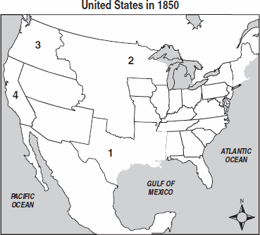

5: Fugitive Slave Law
- What were the provisions of the act?

- What were the results of the act?

- How do you suppose you would have responded to the act if you lived in the North at that time?

6: Underground Railroad
- Why do you think the Underground Railroad was started?

- Harriet Tubman-

7: Kansas-Nebraska Act
- Describe the act.

- What were the results of it?

8: Advertisements
- Compare the 2 advertisements. Who do you suppose was the author of the first one?

The second one?

- What did you notice that was interesting?
1st advertisement:

2nd advertisement:

Overview
Based upon what you have learned, what were the causes of the Civil War? List at least 3.

Could the Civil War have been prevented? Why or why not?

