Entertainment and Culture during the Great Depression
- What were some forms of entertainment during the Depression?

- Which of these forms of entertainment are still popular today? Why do you suppose they are still significant?

Look at the photograph of the couple sitting around the radio and answer the next 2 questions.
- What does the photograph suggest about the prominence of radio in 1930s daily life? How does the photo suggest this?

- Why did the radio appeal to so many different people?

- List several examples of things that people listened to on the radio during the 1930s.

- Why do you think so many people went to the movies during the Great Depression?

- Which, if any, of the movies listed from the 1930s have you seen? What were your opinions of those movies?

- Describe the movie theaters of the 1930s.

- How do they differ from movie theaters today? Why?

Songs: Listen carefully to the word of each song and answer the following questions.
 | What is the song about? | Who does this song speak on behalf of? | What does it reveal about the Depression?
- “Brother, Can You Spare a Dime”

- “We’re in the Money”

- “I Ain’t Got no Home”

- “Strange Fruit”

- “On the Good Ship Lollypop”

Drama
As you listen to the introduction to this radio serial “the Shadow,” think about the main character. What might he represent to the listeners?

Why do you suppose the radio episode “War of the Worlds” sparked so much panic? Would it have the same effect today?

Politics
In the fireside chat, Roosevelt seems to be defending some of his New Deal programs. Why did some criticize the New Deal?

How did Roosevelt answer this criticism?
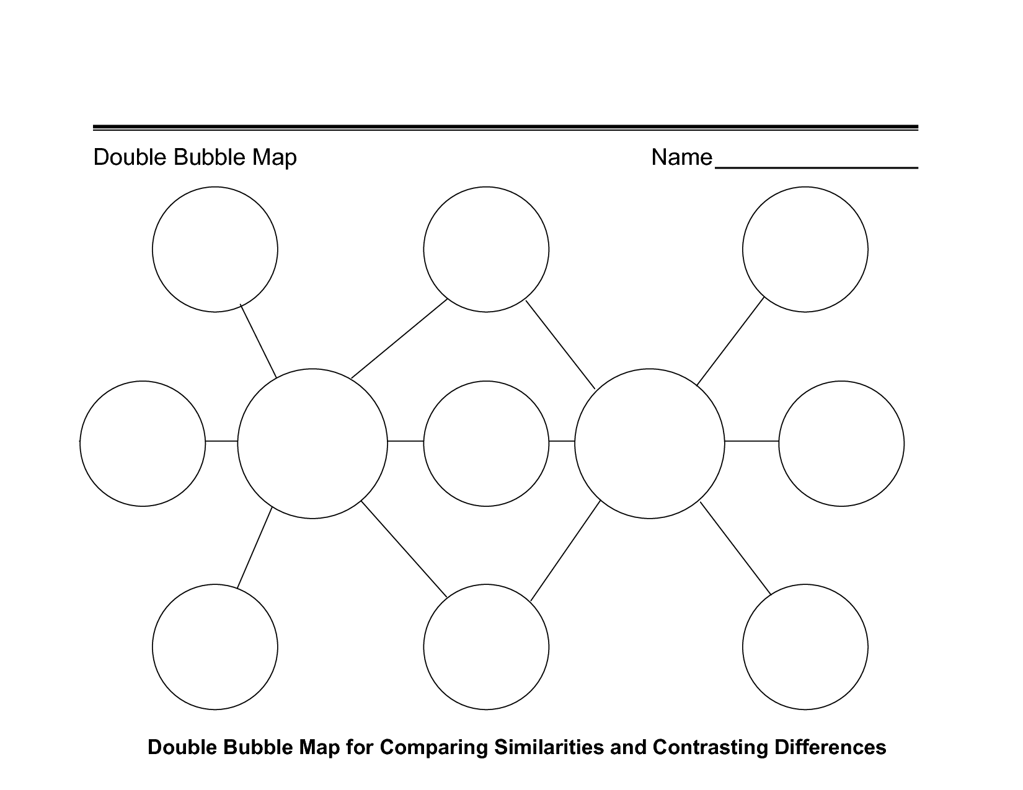
1930s
Culture
Today’s
Culture
Pretend you were alive during the Great Depression. Answer the questions below.
- What was life like for your family during the Great Depression?

- How did you help your family during the Great Depression?

- What did you do for entertainment during the Great Depression?

- What valuable lessons did the Great Depression teach you?

