Name _________________________________

WWI Map Activity: The Geographical Consequences of the Great War

During WWI Map (see map on my website)

1. During WWI Map (see back):

Color and label: (label the nations included as well)

Allied Powers—put in key

Central Powers—put in key

Neutral Nations—put in key

1. Based on the map, what challenge did the Central Powers face at the outbreak of war in 1914?

Map on Strayer page 532:

1. Based on the map, explain why regions in Africa are considered part of the European alliances (Triple Alliance and Triple Entente).

Map on Strayer page 535:

1. Which three regions were lost by Germany as a result of the Treaty of Versailles? Which countries absorbed these new territories?
2. What problems were these German territorial changes designed to eliminate?
3. Which new countries were carved out of the former Austro-Hungarian Empire?
4. Which new nations were created from the former Russian empire?
5. To what extent does the post-war geography of Eastern Europe resemble Eastern European political geography today?
6. Which regions of the Middle East became British Mandates as a result of the Versailles Treaty?
7. Which region of the Middle East became French Mandates as a result of the Versailles Treaty?
8. Which was the only region of the former Ottoman Empire to become an independent nation after World War I?

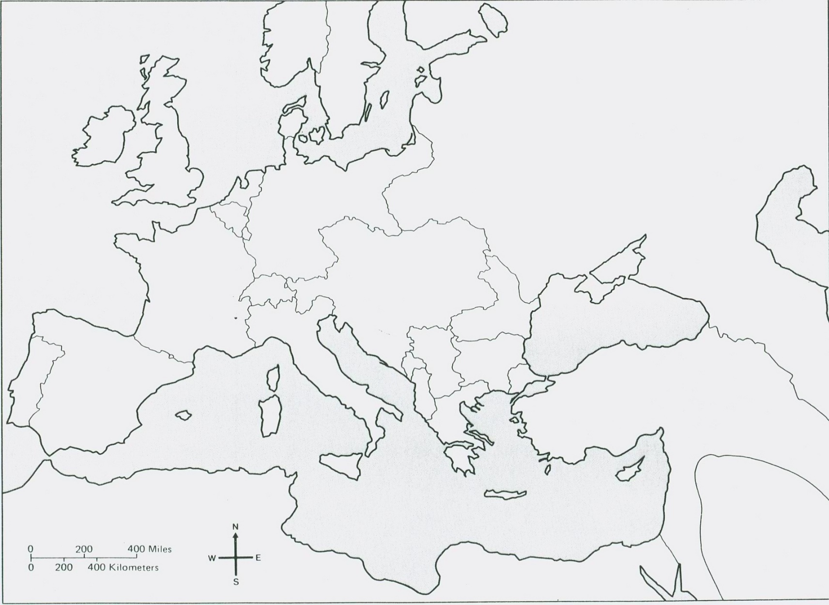During WWI Map