Name ____________________________________
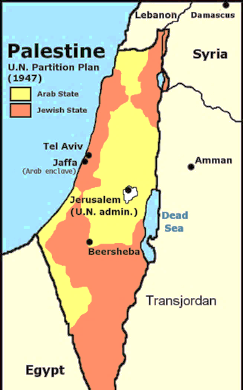
Israel/Palestine Conflict
Part 1: Background
To Jews, their claim to the land dates back 3,000 years, when Jewish kings ruled the region from Jerusalem. To Palestinians (both Muslim and Christian), the land has belonged to them since the Jews were driven out around 135 CE. To Arabs, the land has belonged to them since their conquest of the area in the 7th century.
During the late 19th and early 20th centuries, a group of Jews began returning to the region their ancestors had fled so long ago. They were known as Zionists, people who favored a Jewish national homeland in Palestine. At this time, Palestine was still part of the Ottoman Empire, ruled by Islamic Turks. After the defeat of the Ottomans in World War I, the League of Nations asked Britain to oversee Palestine until it was ready for independence.
Before 1948, the word “Palestine” was used to describe the area of the Middle East from the Mediterranean Sea to the Jordan River. In 1948, the United Nations partitioned the area into 2 nations: Israel (Jewish) and Palestine (Arab). Jerusalem was to be an international city owned by neither side.
The new nation of Israel got a hostile greeting from its neighbors. The day after it proclaimed itself a state, six Islamic states—Egypt, Iraq, Jordan, Lebanon, Saudi
Arabia, and Syria—invaded Israel. The first of many Arab-Israeli wars, this one ended within months in a victory for Israel. Largely as a result of this fighting, the state that the UN had set aside for Palestinians never came into being. Full-scale war broke out again in 1956, 1967, and 1973.
- The Jews were driven out of Israel in the year _____________.
- Zionists-

- What happened to the Ottoman Empire after WWI? (think back to what we learned earlier)

How did this impact Palestine?

- What did the UN do to Palestine in 1948?

Why do you think they did this?

- Immediately after the partition of Palestine occurred, what occurred? Who did this?

Why do you suppose they did this?

- Color the map above—Palestine 1 color, Israel another color.
- Do you see any problems that might arise based upon how the UN partitioned it? (see map)
Part 2: Primary Sources
“These people have walked off with our home and homeland, with our movable and immovable property, with our land, our farms, our shops, our public buildings, our paved roads, our cars, our theaters, our clubs, our parks, our furniture, our tricycles. They hounded us out of ancestral patrimony [land] and shoved us in refugee camps. . . . Now they were astride the whole of historic Palestine and then some, jubilant at the new role as latter day colonial overlords.”
Fawz Turki, Palestinian—expelled from Israel in 1949, currently a Saudi Arabian journalist, The Arab-Israeli Conflict

“Since the establishment of the State of Israel, its national security policy has been designed to defend its existence, integrity and security, and not for expansionist territorial aspirations. Hence, if Arab confrontation states did not initiate wars against Israel or pose threats to its existence, then Israel would not start a war . . . to extend its territories . . . Our national security policy created from its very beginning the linkage between Israel’s political willingness for peace and Israel’s military capability to repel aggression of any kind and scale.”
Abraham Tamir, Israeli professor, From War to Peace

- Why does Fawaz Turki refer to the Israelis as colonizers?

- What might be the best way for the Palestinians to regain control of their land, according to Abraham Tamir?

Part 3: Images/Cartoons
- Image 1: What is the significance of this image? To whom?

- Image 2: What is the significance of this image? To whom?

- Cartoon 1: What is the significance of the word that is crossed out? Why?

- Cartoon 2: What is the message of this cartoon?

- Cartoon 3: What is the POV of the cartoonist? How can you tell this?

- Cartoon 4: What is the POV of the cartoonist? How can you tell this?

Part 4: Timeline of Israel-Palestine Conflict

Part 5: Current Map
- Color Palestine one color and Israel another color.
- Highlight: Jerusalem, Gaza Strip, and the West Bank.
- Looking at this map do you think a 2 nation theory would ever work?

Part 6: Overview
- Why do you think all the Israeli-Palestinians accords at peace have ultimately failed?

- Some have said that the Palestinian-Israeli conflict represents the struggle of right against right. Explain why you agree or disagree.

