Napoleon’s Empire

Use the map on:

* page 634 in your textbook

Label and color with colored pencils the following areas:

Color orange—Enemies of Napoleon

* Portugal
* Great Britain (United Kingdom )
* Russia

Color green—French Empire

* French Empire

Color purple—Nations Dependent on France

* Spain
* Confederation of the Rhine
* Italy
* Grand Duchy of Warsaw

Color Yellow—Allied with Napoleon

* Austrian Empire
* Prussia

Create a key based on the above groups.

Label the following bodies of water AND color them blue.

* Atlantic Ocean
* Mediterranean Sea
* North Sea
* Baltic Sea

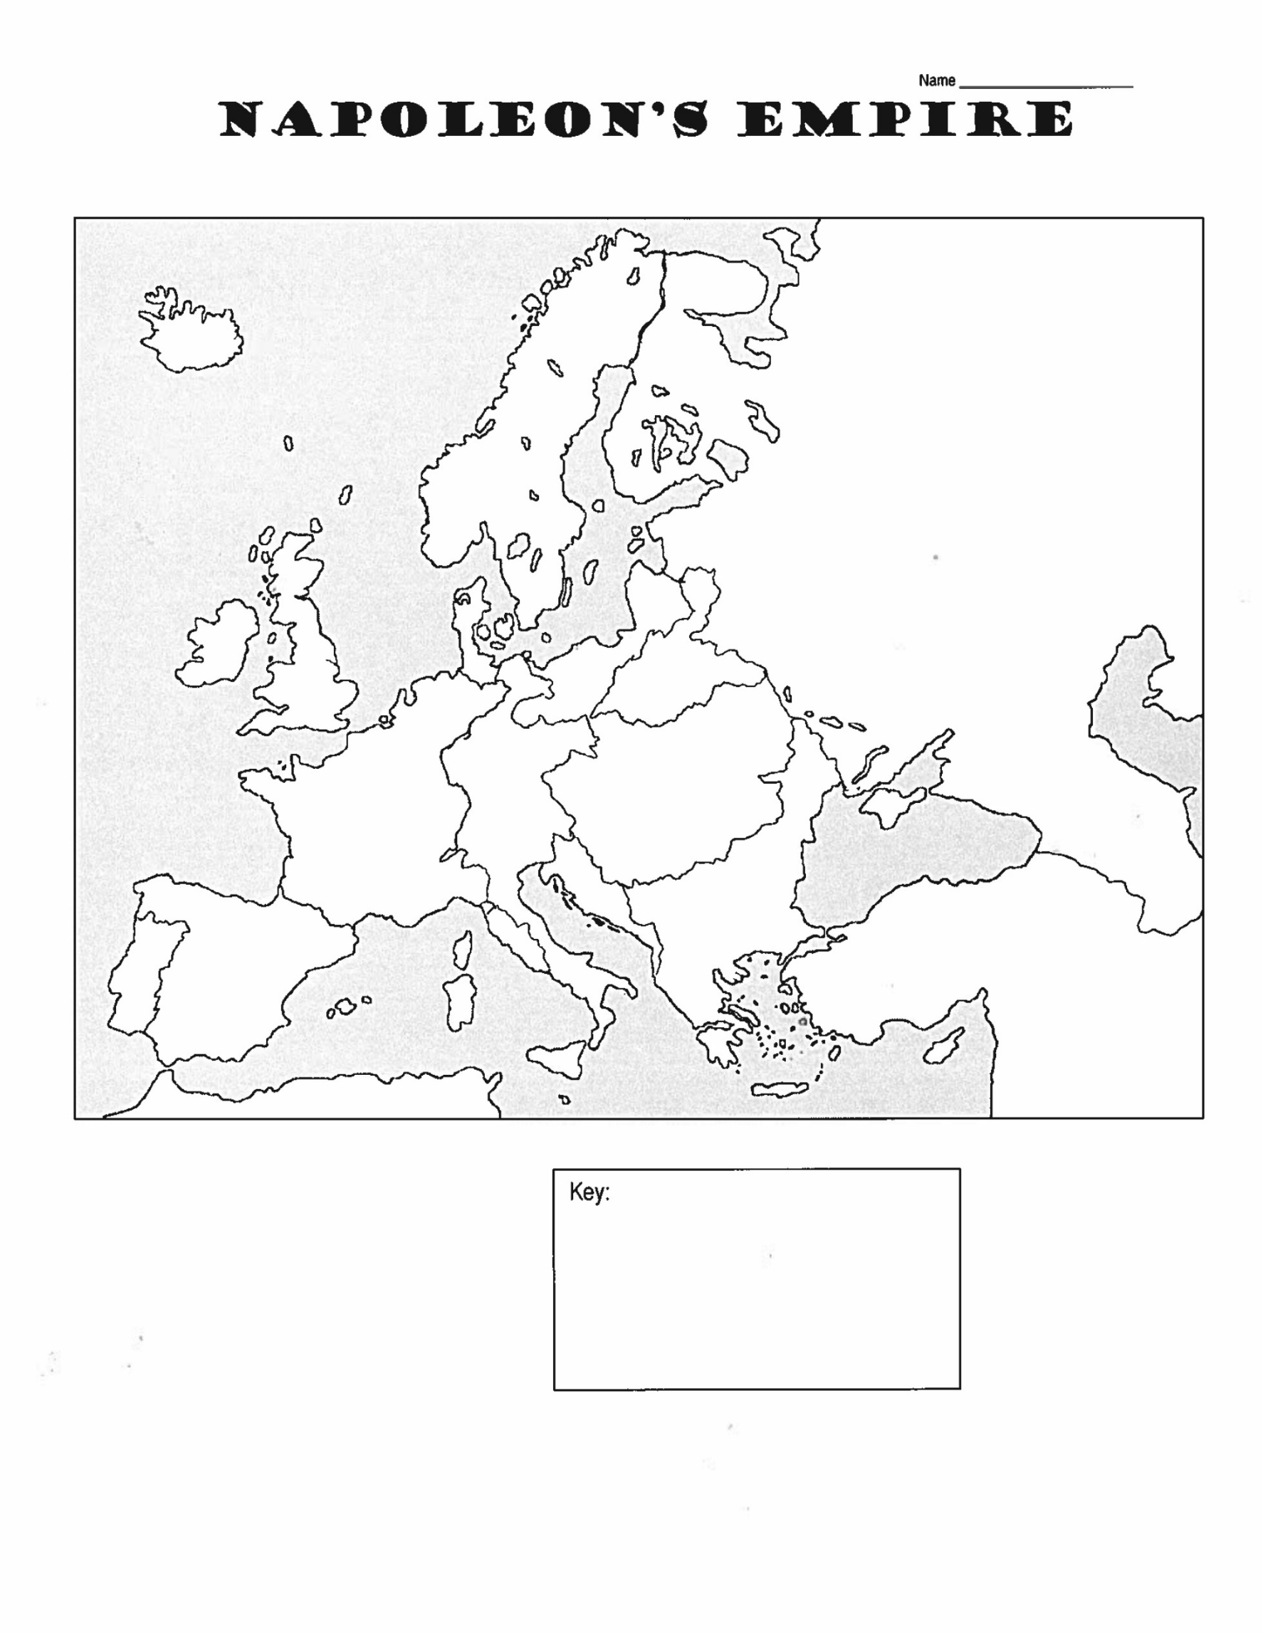

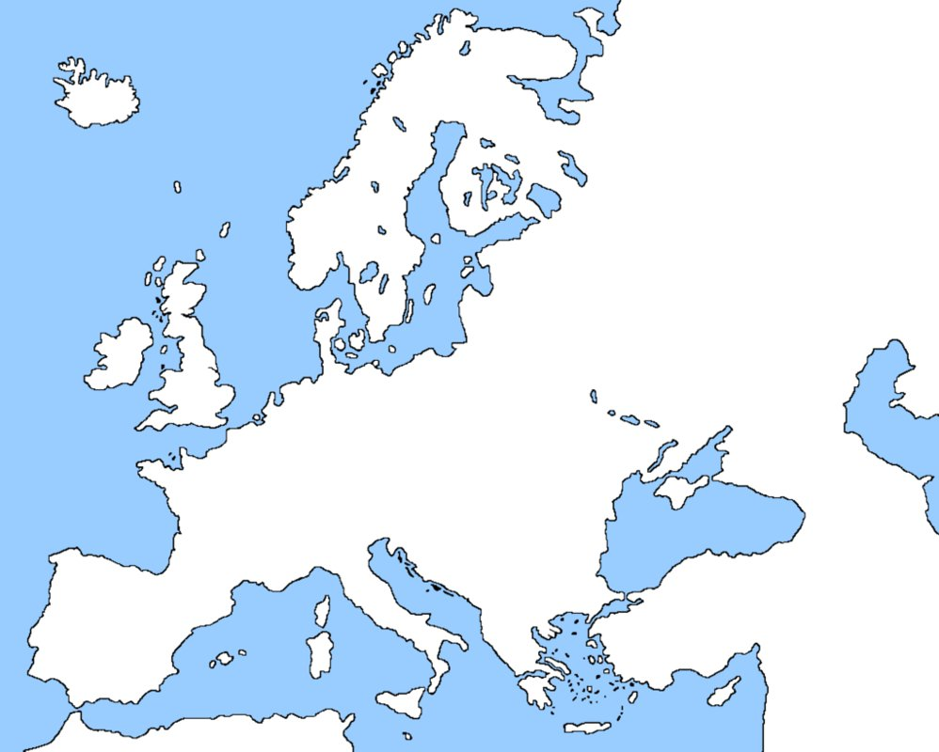

Name _______________________

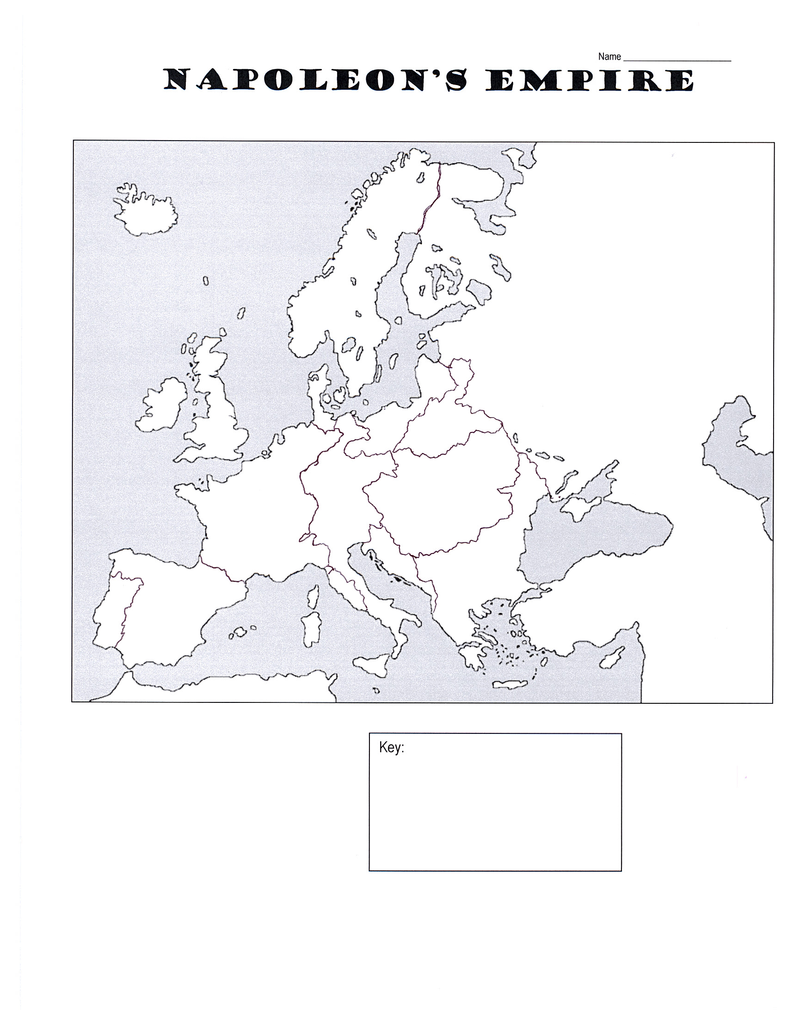Napoleon’s Empire

Key: