Name _______________________________________________
Map Activity- Byzantine and Western Europe

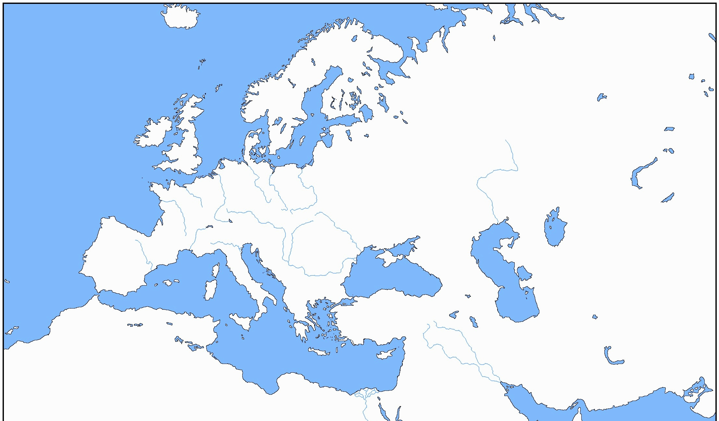
Directions: Complete the following items. Use colors on your map to make the regions easier to identify. Use the following pages in your Strayer textbook: 70, 76, 82 (pdf 125, 131,137) (and the map on my website).
Key:

Crusades
Hanseatic League

Map Directions: Use the map on my website and your textbook to do the following.
- Color AND label the Byzantine Empire under Justinian (see page 70).

- Color (each one different color than neighboring states) AND label the following states:
Holy Roman Empire Spain (Castile, Granada, Aragon) France Papal States
Naples Poland-Lithuania Denmark England
Scotland Serbia Hungary Republic of Venice

- Find and label the cities of:
Rome Venice London Paris
Constantinople Jerusalem

- Find and label the following bodies of water and color them blue:
Mediterranean Sea Black Sea Red Sea Baltic Sea North Sea

- Using the map on page 82, draw in the route of the First Crusade and label the color on your key.

Map Questions:
- Using the maps on pages 70 and 76: What happened to the control of the Byzantine Empire?

- Using the maps on pages 70 and 76: What happened to the map of Western Europe from the time of the fall of Rome (476 CE) to the time of the Middle Ages around 1453? Make observations and include evidence.

- Using the visuals on page 72 (pdf 127), describe the major aspects and subject matter of Byzantine art? BE SPECIFIC.

- Based upon your reading, what were the major lasting impact the Crusades on Western Europe?

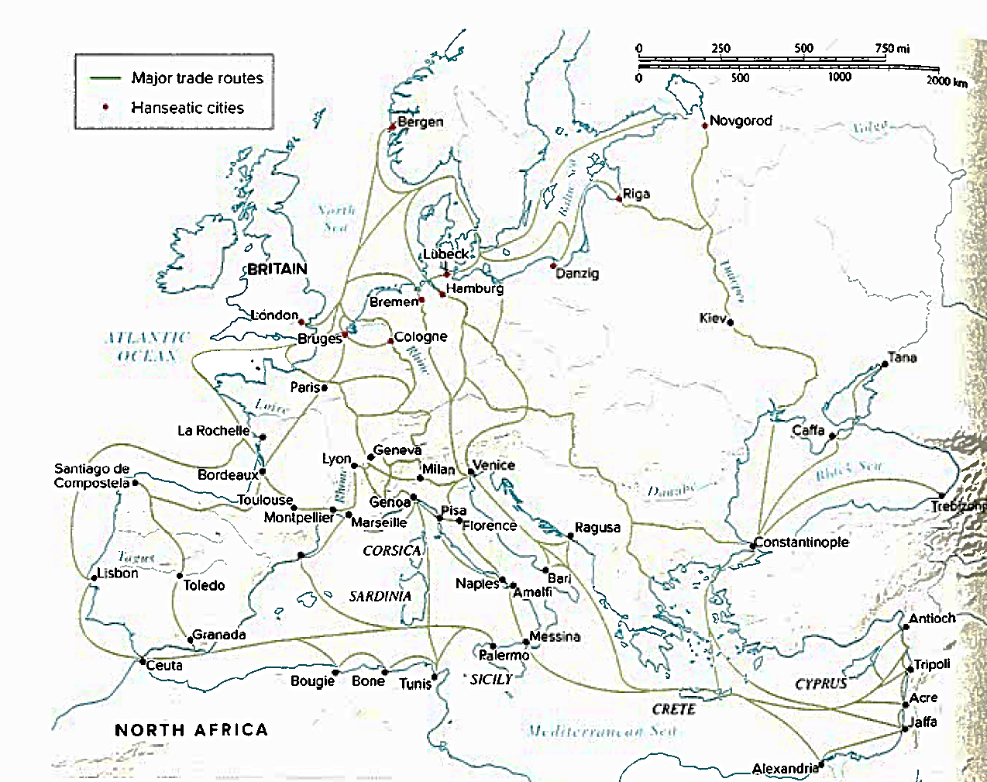
Read the section below on the Hanseatic League.
Although medieval trade was most active in the Mediterranean basin, a lively commerce grew up also in the northern seas. The Baltic Sea and North Sea were sites of a particularly well-developed trade network known as the Hanseatic League, or more simply as the Hansa—an association of trading cities stretching from Novgorod to London and embracing al the significant commercial centers of Poland, northern Germany, and Scandinavia. The Hansa dominated trade in grain, fish, furs, timber, and pitch from northern Europe. The fairs of Champagne and the Rhine, the Danube, and other major European rivers linked the Hansa trade network with that of the Mediterranean.

- Summarize it below.

- What were the benefits to being part of this league?

- Look back at the map above. On your map draw in a few of the trade routes that were used by the Hanseatic League and label the color on your key.

