WWII Map

ONLY use colored pencils on maps. No markers or highlighters.

WWII Europe Map—Use the map on p. 744.

- Label and color code [pick 3 different colored pencils] the Allied, Axis, and Neutral nations of Europe—create a key.
Allied: Great Britain, France
Axis: Italy, Germany (include East Prussia)
Neutral: Portugal, Spain, Ireland, Sweden,Turkey

- Color [with a different color] and label (with year) German invasions of:
1938: Czechoslovakia, Austria
1939: Poland
1940: Belgium, Netherlands, Denmark, Norway, France
1941: Hungary, Yugoslavia, Soviet Union Latvia, Estonia, Lithuania, Greece

Color ALL of the water blue!!!

WWII Pacific Map—use the map on page 762.
- Label and color Japan—the same color you used on the above map for the Axis Nations.

- Label and color areas under Japanese control.
Manchuria, French Indochina

- Color the extent of the Japanese control line.

- Create a key for the map.

Color ALL of the water blue!!!

Name __________________________
World War II Europe Map
Key:
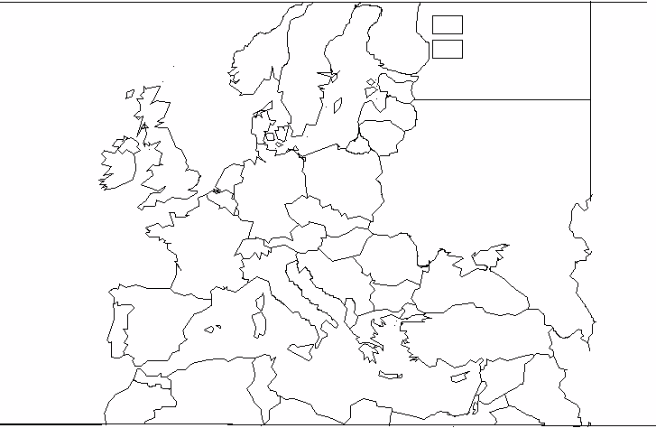
WWII Pacific Map
Key:

