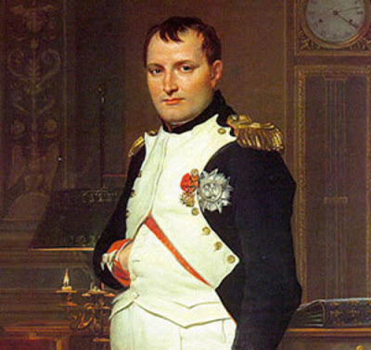

Napoleon’s Empire

1. How tall was Napoleon?
2. Why Napoleon was hailed a hero?
3. In 1796, he was appointed to lead the _________ to victory against the Austrians across the Alps.
4. What happened in Egypt?—who did he loose to and why?
5. Discuss Napoleon’s actions in November 1799. (This is a big deal!!!)
6. coup d’etat-
7. plebiscite-
8. Concordat with Pope-
9. Napoleonic Code-
10. What happened in 1804?
11. What did he do when he approached the pope?
12. Louisiana Territory in 1803- (why did he sell it?—several reasons)
13. Eventually, the rulers of Austria, Prussia, and Russia all signed ____________________ with Napoleon making it the largest empire since the _______________.
14. Battle of Trafalgar- (fought with what nation, against what general, who won)
15. Two effects of the battle-
16. By 1812, the only major European countries free from Napoleon’s control were: