Cold War Map

Use the Cold War map on my website or you can reference page 811 in your textbook to label the nations in correct location.

NATO Alliance—color with the same color and label the following:
Iceland United Kingdom Norway Portugal Spain
Netherlands Belgium Luxemburg West Germany
Denmark Italy Greece Turkey

Warsaw Pact-- color with the same color and label the following:
Soviet Union Poland East Germany Czechoslovakia
Hungary Romania Bulgaria Albania

Neutral Nations—color with the same color and label the following:
Ireland Sweden Finland Switzerland Yugoslavia

Make a key.
Name ______________________
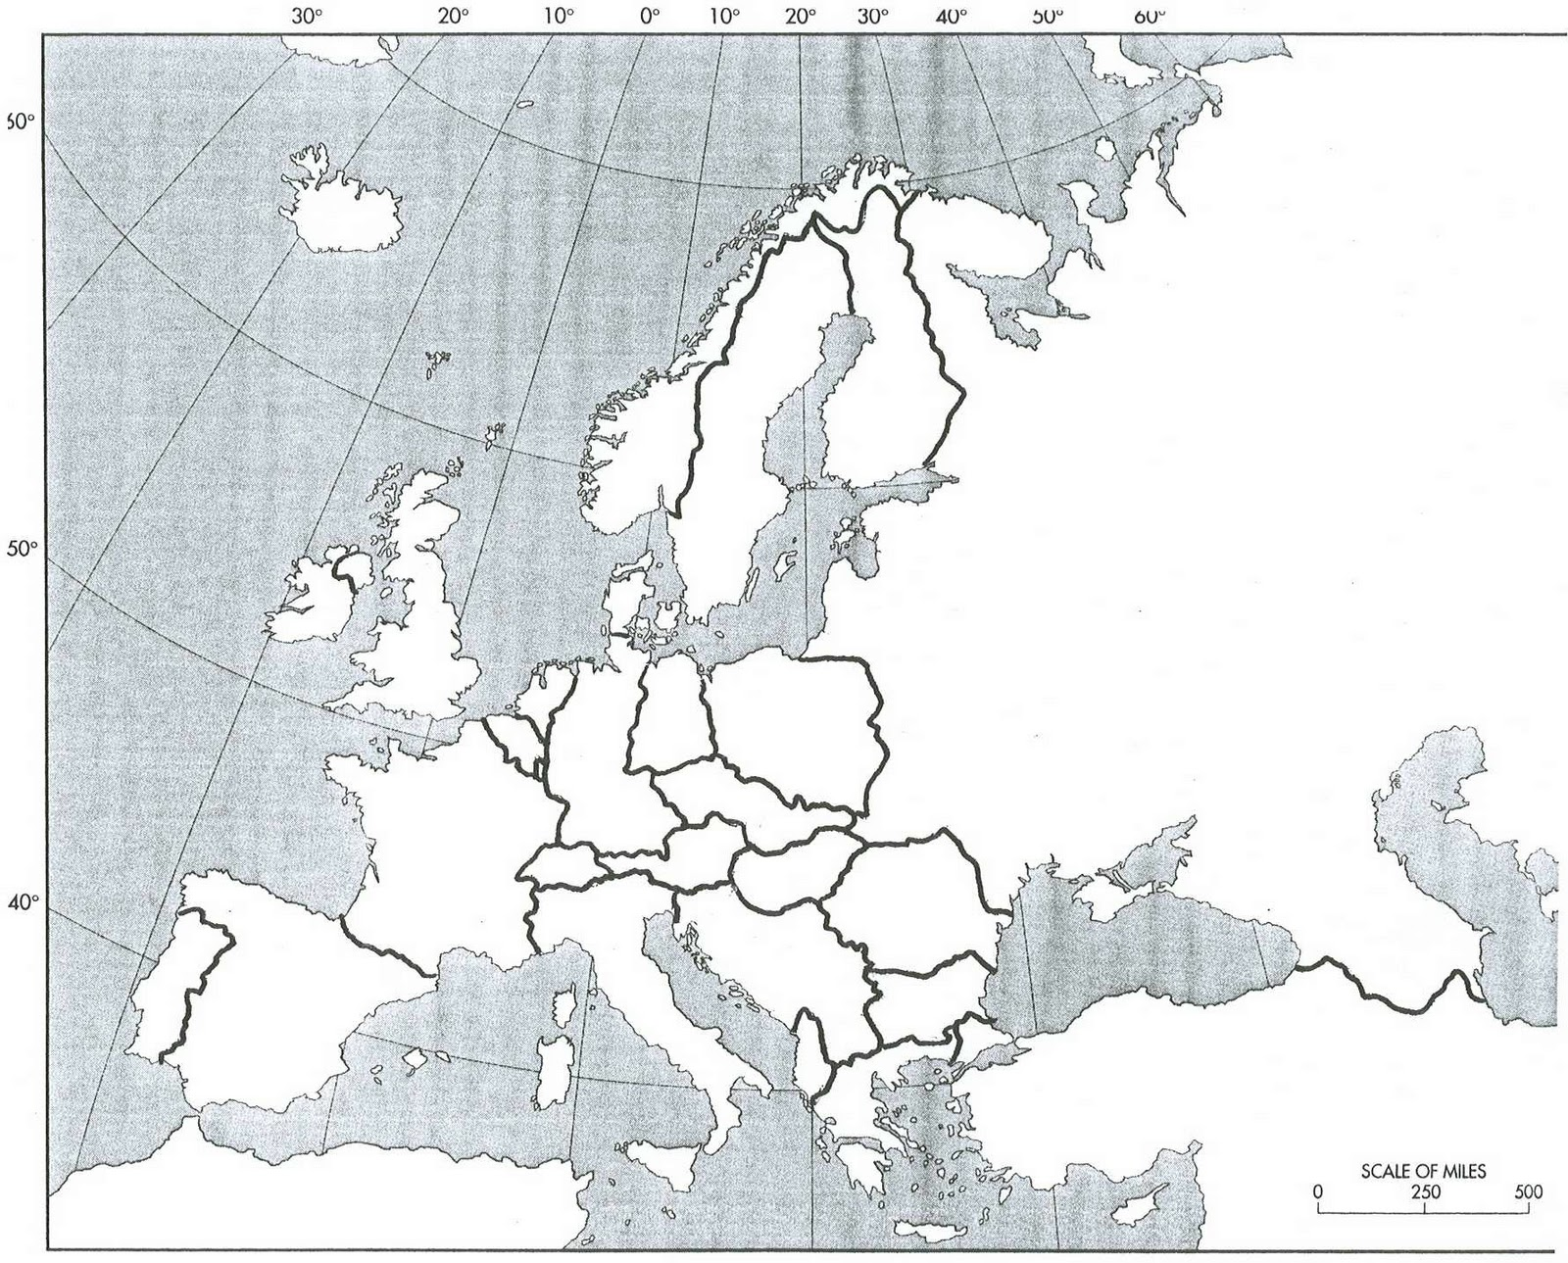
Cold War Map

