WWII Begins Activity
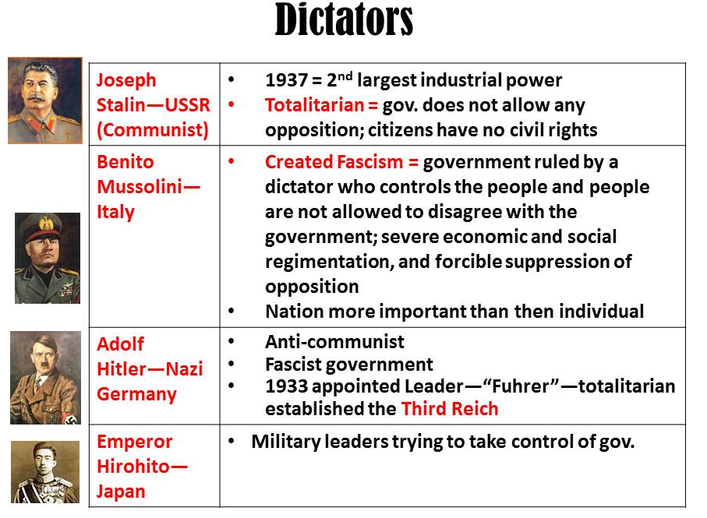
Dictators Chart
- Based on the chart, why do you think it is significant that the USSR is the second largest industrial power?

- What can you note about the similarities between fascism and communism (totalitarianism)?

- What occurred in 1933 in Germany?

What do you think enabled this to occur? (think of your reading from last night)

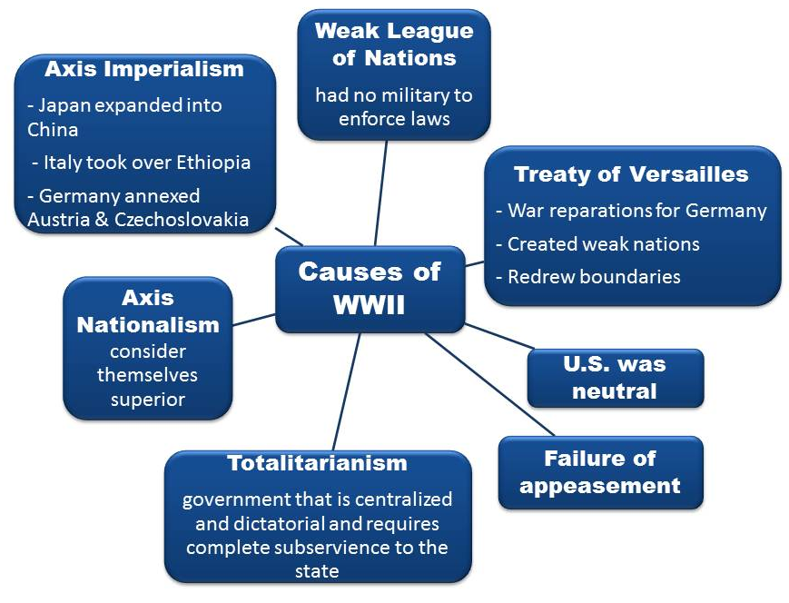
- Why do you suppose Italy and Germany formed an alliance with Japan?

Causes of WWII
- What does “failure of appeasement” mean? (feel free to use your phone to look up the word “appease”)

- Why do you suppose the U.S. remaining neutral was a cause of WWII?

- How did the Treaty of Versailles cause WWII?

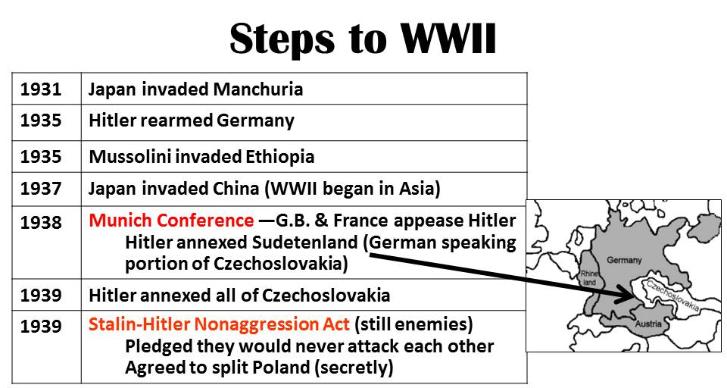
- Which of the causes do you feel was the most significant? Why?

- The least significant? Why?

Steps to WWII
- When did WWII begin in Asia? Why?

- Explain the Munich Conference.

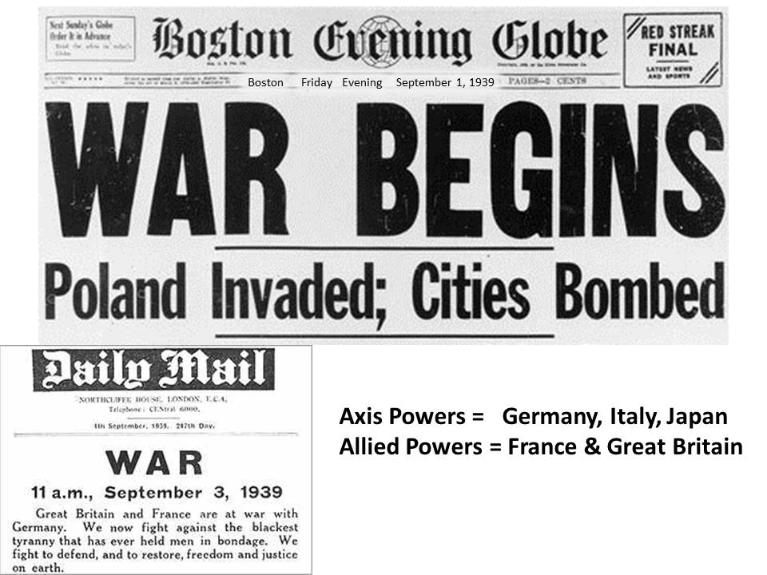
- Why was it a problem that Hitler annexed Czechoslovakia?

- Why do you think it was significant that the Stalin-Hitler Nonaggression Act was signed?

WWII Begins
- WWII began on when Germany invaded ________________ on _________________ (date).
- Why do you think France and Great Britain get involved so quickly?

(the next 2 slides are notes to fill in during class)
