Dictators of the 20th Century
Dictator | Background info. (3) | Rise to Power (4) | Key Aspects of Dictatorship (5)
Mussolini/ Italy
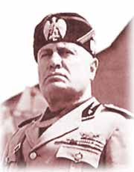

Hitler/ Germany

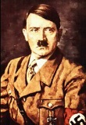

Stalin/ Soviet Union
