Entertainment and Culture during the Great Depression

Entertainment
Although the 1930s was a time of great hardship, people still found ways to have fun. For many during these years, having fun didn't have to cost much. Everything was homemade – the food, the games, the music – there were even homemade portable dance floors. But traditional organized activities – like rodeo and football – were popular as well.
Neighbors got together to play cards and other games and to talk. Church socials and school programs gave people a chance to visit and maybe meet someone new. Soda fountains and local dances gave young people a chance to enjoy themselves and to go on dates.
Popular culture was alive and well. Children read about Superman in Action Comics and followed the adventures of Flash Gordon, Dick Tracy, and Terry and the Pirates in newspaper comic strips. Adults loved to read about the exciting lives of rich people in big cities.
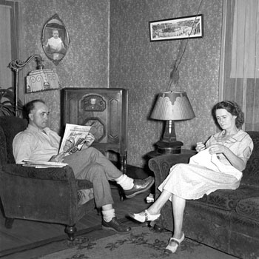
During the Depression, people still had fun, just not lavishly expensive fun. Children had soapbox derbies, teenagers had dance contests, and everyone played Monopoly, did puzzles, read, and listened to the radio.

The Radio
The first commercial radio broadcast was transmitted from Pittsburgh in 1920. In the following years, the radio industry grew rapidly. The scope of the programming widened to include music, news, sports, and political shows.
The Great Depression drove down the average price of a radio sold in United States from $139 in 1929 to about $47 just four years later. But the brutal market forces of the early depression did not stop Americans from buying radios; by the end of the 1920s, one third of U.S. households owned a radio and by 1933 that number climb close to 60%. For the radio, the 1930s was a golden age. At the start of the decade 12 million American households owned a radio, and by 1939 this total had exploded to more than 28 million.
As technology improved radios became smaller and cheaper. They became the central piece of furniture in the average family’s living room, with parents and children alike, crowding around the set to hear the latest installment of their favorite show. Radio may have had such mass appeal because it was an excellent way of uniting communities of people, if only virtually.
It provided a great source of entertainment with much loved comedians such as Jack Benny and Fred Allen making their names on the wireless. It marked the advent of the soap opera, a running story that people could return to, with characters they could sympathize with and love.
Radio programs provided a source of inspiration, with heroes like the Lone Ranger and the Shadow getting embroiled in deadly capers. But they also promoted old-fashioned American family values and gave people a model to live by. On Wednesday nights at 8pm when the public tuned in to “One Man’s Family” they were greeted with the opening: “Dedicated to the mothers and fathers of the younger generation and to their bewildering offspring.”
News broadcasts also influenced the way the public experienced current affairs. When the Hindenburg airship exploded in 1937, reporter Herb Morrison was on the scene, recording the events to be broadcast the following day.
But above all the radio provided a way to communicate like never before. Franklin Roosevelt’s ‘fireside chats’ helped the population feel closer to their president than ever.
By the end of the decade radio had exacted quite an influence on the American media. Advertisers capitalized on radio’s popularity and the idea of the ‘sponsor’ was born. Radio also helped establish the national broadcasting networks such as NBC and CBS, still present to this day. After the 1930s the popularity of radio began to decline at the hands of newer, more visual technologies. But the influence of the golden age of radio on the American way of life will never be forgotten.

Movies
Movies provided an escape from the hardships of the Great Depression, allowing a glimpse into high society life, so far from rural life. People were fascinated by the movies themselves and by the glamorous lives of the men and women who starred in the films. For example, the movie "My Man Godfrey" told the story of a man who lost his entire fortune in the 1929 stock market crash. To make a living, he became a butler for a rich family, and he ended up saving the family.
Merchants in small towns decided to show free movies to draw country folks in to town on Thursday evenings. They projected the film on the wall of a downtown building.
While thousands of people struggled to find a paying job, Hollywood entered a golden age. Despite the costs of an evening out, two out of every five Americans saw at least one movie per week. People flocked to watch movie stars Clark Gable, Bette Davis, Greta Garbo, Errol Flynn, Humphrey Bogart, little Shirley Temple, and elegant dancers Fred Astaire and Ginger Rogers. Comedians W.C. Fields, Bob Hope, the Marx Brothers, and others made people laugh and forget their troubles. In 1937, Walt Disney's "Snow White" became America's first full-length animated movie. "Gone with the Wind" premiered in Atlanta in 1939.
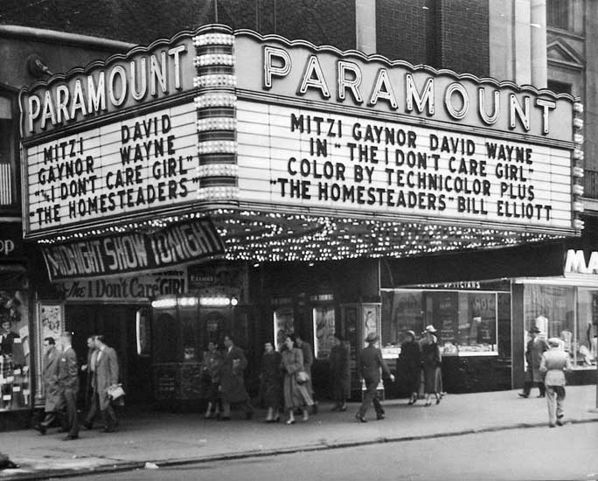
Many of the movie theatres of the 1920s and 1930s were so grand that people nicknamed them "picture palaces." Exteriors were gaudy, electric extravaganzas in the style of art deco, Middle Eastern or Asian architectures.
Where else could you sit in the courtyard of a Moorish or Spanish palace under a twilight sky complete with clouds and stars and watch a first run movie? It didn't matter that the palace was plaster; the clouds were painted and stars artificial lights. During the dark days of the depression, visits to the movie theatre were welcome relief to the hard times of the day.
Inside the palaces, smartly uniformed ushers led moviegoers through luxurious marble-lined halls the size of cathedrals, under crystal chandeliers, and up plushly carpeted stairs to their seats. They offered every convenience, including restaurants, nurseries for children, free telephone calls, art galleries, dance floors, and billiard rooms. While waiting for the film to start, patrons could be entertained by a ballet, orchestral music, the organ or other stage attractions.
The aim of grand theatres was to encourage people to see films frequently. The tactic worked well: In 1930, at the start of the Depression and when the population of the United States was 122 million, Americans were going to the movies 95 million times each week.
During the 1930s, many gimmicks were used to lure people into the theatres.
- Ladies night, which featured lower rates for women.
- Free dishes: Faithful attendees could accumulate complete household sets. This practice is how depression glassware got its start.
- Cheap Saturday afternoon matinees for kids, often with free ice cream.
- Raffles for appliances and even automobiles.

http://www.pbs.org/opb/historydetectives/feature/radio-in-the-1930s/
http://www.ushistory.org/us/48e.asp

