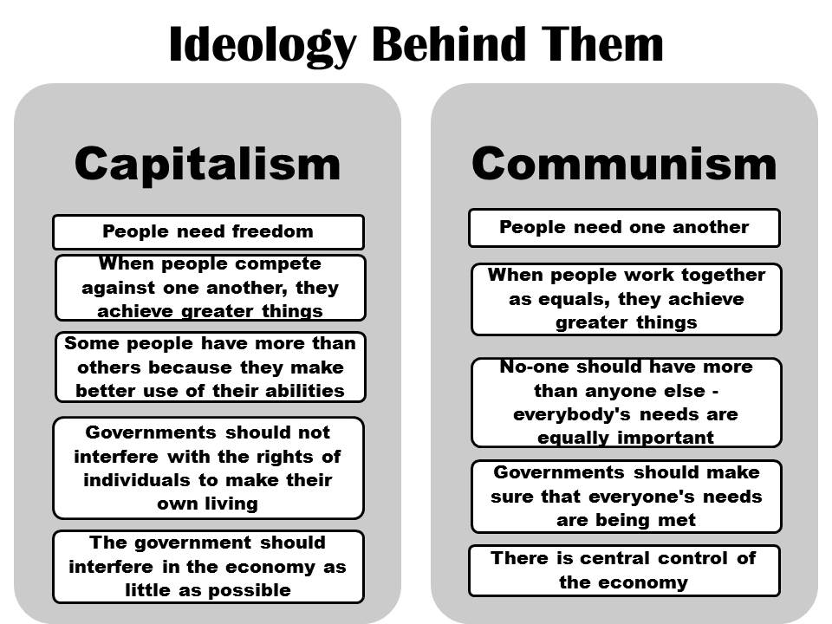
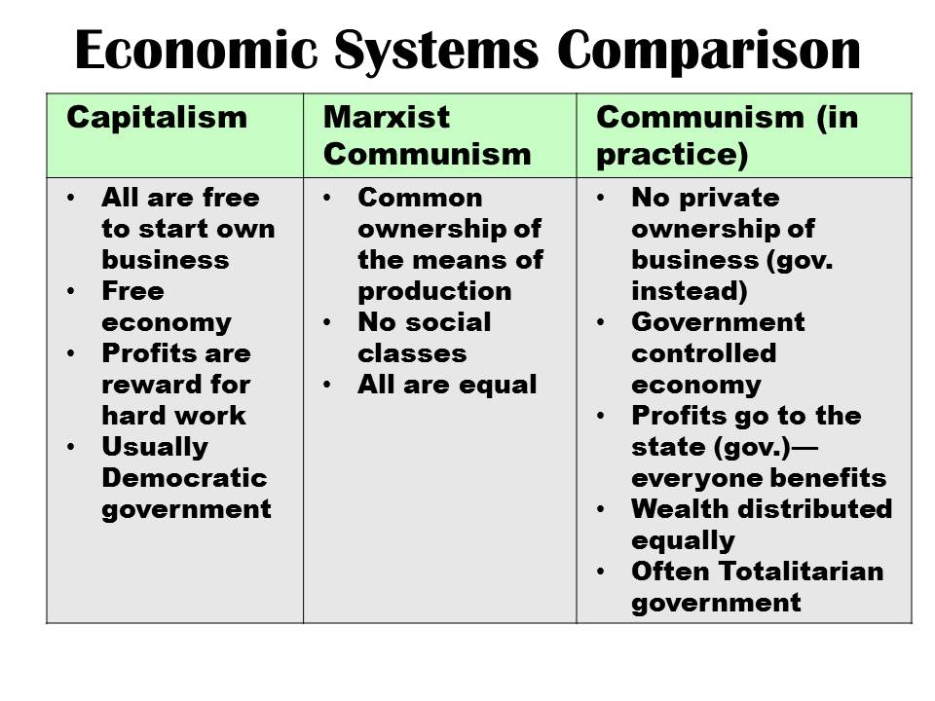
Capitalism vs. Communism
Capitalism vs. Communism
Capitalism vs. Communism

