North Korea Nuclear Debate Activity
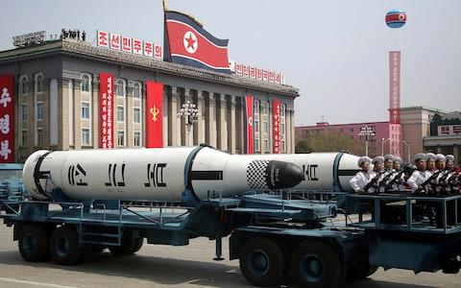
Part 1: Read the article and answer the following question.
- What percent of North Korea’s foreign trade is with China? __________ Why do you think this is an important fact?

- Originally, North Korea was a Marxist-Leninist state, yet after 1972 it is “______________________.”
- The state owns all _______________________, ________________________, and ________________. What basic freedoms do the people NOT have?

- The U.S. has ____________________nuclear warheads. North Korea has between _______ and _______ nuclear warheads. Since the number is so drastically different, why do you think North Korea is a concern?

- What are the potential consequences of nuclear war with North Korea? (not just human lose)

- What did North Korea do in 2003 that was concerning?

- What occurred in 2017?

- How have Kim Jung-Un and President Trump responded to each other?

- U.S.—Options for dealing with the nuclear crisis
U.S. Options | Explanation | Pros | Cons
1: Direct military confrontation

2: Direct diplomacy with North Korea

3: Containment

4: Multilateral diplomacy

5: Rely on China to pressure North Korea

Part 2: Process the reading.
- Article I, Section 8 of the U.S. Constitution gives Congress the power to “declare war.” The president has power as commander-in-chief, however to initiate military actions against other nations. Do you think only Congress should be able to authorize nuclear strikes against North Korea? Explain your answer.

- Which of the U.S.’s options for dealing with North Korea’s nuclear weapons is best? Explain.

- Which option is the worst? Explain.

- In the article, I agree with…

- In the article I disagree with…

- Write down 1 question you will ask your small group based upon the issue of North Korea’s nuclear weapons. These MUST be level 3 questions (see below).
Level 3: answers to the questions require you to think; can be moral questions
Key words: evaluate, judge, if/then, predict, imagine, hypothesis, speculate, forecast
Is…ethical, what is your opinion on…, what is the best solution…
Example: If Kennedy had survived the assassination, how different do you think history would be?
Should anyone be held accountable for the Kennedy assassination? Why? How?

Part 3: Civil Conversation
In small groups assigned by the teacher you will discuss the issue of North Korea’s nuclear weapons. You can discuss any of the questions in part 2 (or the chart on part 1).

