U.S. Entry into WWII

Two days after Britain and France declared war on Nazi Germany, President Roosevelt issued a proclamation of neutrality and ordered the suspension of munitions sales to all belligerents. But Roosevelt stopped short of asking that Americans remain emotionally neutral in the European conflict. FDR knew that the only chance Britain and France would have to defeat the German Reich was to have ample supplies of weaponry. He immediately began to press Congress to repeal the Arms Embargo (1935 law stating the U.S. would not sell arms to any nation at war).
The request was simple. Allow trade of munitions with belligerent nations on a "cash and carry" basis. There would be no danger to American shipping if the Allies had to carry the supplies on their own ships. Isolationists were concerned, but support for the President's initiative was strong enough. The Neutrality Act of 1939 ended the arms embargo and permitted the sales of munitions on a "cash and carry" basis.
Not to be outdone by the swelling "Arsenal of Democracy," German production increased as well during World War II.
New Prime Minster Winston Churchill desperately pleaded with Roosevelt for assistance. In the summer of 1940, Hitler launched Operation Sea Lion, an all-out assault on the British mainland. The Royal Air Force of Britain battled the German Luftwaffe in the greatest air battle in history as Americans watched nervously.
Miraculously Britain held its own with Germany while America deliberated. In September 1940, the United States agreed to the transfer of 50 old destroyers to the British fleet in exchange for naval bases in the Western Hemisphere. By directly aiding the Allies, America could no longer hide behind the shield of neutrality. At Roosevelt's urging, Congress authorized the construction of new planes to defend America's coast. Congress also enacted the first peacetime draft in the nation's history in September 1940. The interventionist argument seemed to be prevailing, but debate continued into 1941.
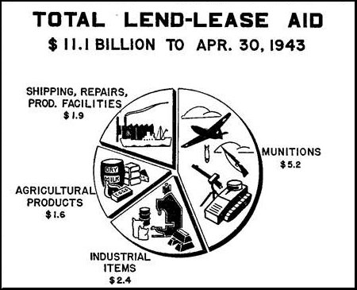
The Destroyer Deal was helpful, but Britain simply did not have the financial reserves to pay for all the weapons they needed. Roosevelt feared another postwar debt crisis so he hatched a new plan called the Lend-Lease Act. Roosevelt publicly mused that if a neighbor's house is on fire, nobody sells him a hose to put it out. Common sense dictated that the hose is lent to the neighbor and returned when the fire is extinguished. The United States could simply lend Great Britain the materials it would need to fight the war. When the war was over, they would be returned. The Congress hotly argued over the proposal. Senator Robert Taft retorted: "Lending war equipment is a good deal like lending chewing gum. You don't want it back."
In March 1941 after a great deal of controversy, Congress approved the Lend-Lease Act, which eventually appropriated $50 billion of aid to the Allies. Meanwhile Roosevelt began an unprecedented third term. Neutrality was no longer a façade behind which America could hide. Hitler saw Lend-Lease as tantamount to a war declaration and ordered attacks on American ships.
Congress still vacillated. Roosevelt met with Churchill in the summer of 1941 and agreed to the Atlantic Charter, a statement that outlined Anglo-American war aims. The Charter stated the ideal goals of the war: no territorial gains; no territorial changes made against the wishes of the people; restoration of self-government to those deprived of it; reduction of trade restrictions; global cooperation to secure better economic and social conditions for all; freedom from fear and want; freedom of the seas; and abandonment of the use of force, as well as disarmament of aggressor nations.
At this point, the United States was willing to commit almost everything to the Allied war machine — money, resources, and diplomacy. The only thing missing were American troops.

Pearl Harbor
While the international picture in Europe was growing increasingly dimmer for the United States, relations with Japan were souring as well. Japan's aggression was literally being fueled by the United States. The Japanese military machine relied heavily on imports of American steel and oil to prosecute its assault on China and French Indochina.
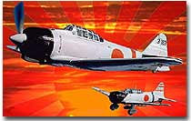
Placing a strict embargo on Japan would have seemed obvious, but Roosevelt feared that Japan would strike at the resource-laden Dutch East Indies to make up the difference. Beginning in late-1940, the United States grew less patient with Japanese atrocities and began to restrict trade with the Empire.
By the end of 1940, the United States had ended shipments of scrap metal, steel, and iron ore to Japan. Simultaneously, the United States began to send military hardware to the Chinese forces resisting Japanese takeover.
Negotiations between Japan and the U.S. began in early 1941, but there was little movement. By midsummer, FDR made the fateful step of freezing all Japanese assets in the United States and ending shipments of oil to the island nation. Negotiations went nowhere. The United States was as unwilling to accept Japanese expansion and Japan was unwilling to end its conquests.
American diplomats did, however, have a hidden advantage. With the help of "Magic," a decoding device, the United States was able to decipher Japan's radio transmissions. Leaders in Washington knew that the deadline for diplomacy set by Japan's high command was November 25. When that date came and passed, American officials were poised for a strike. The prevailing view was that the attack would focus on British Malaya or the Dutch East Indies to replenish dwindling fuel supplies.
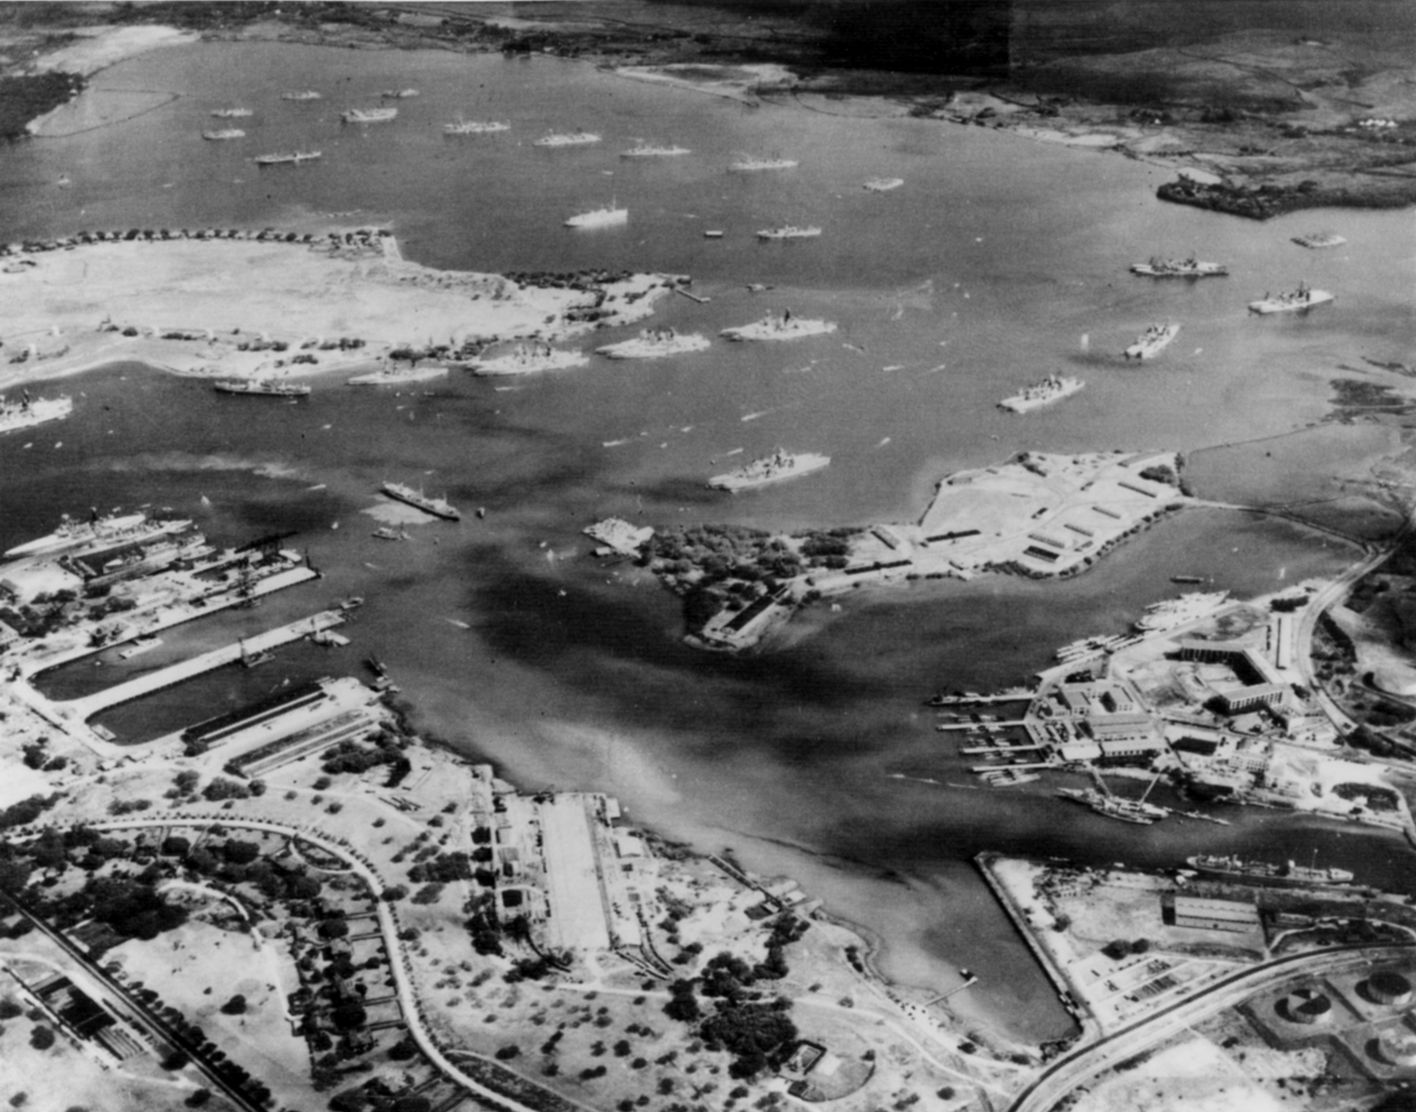
Unbeknown to the United States, a Japanese fleet of aircraft carriers stealthily steamed toward Hawaii.
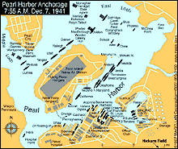
The goals for the Japanese attack were simple. Japan did not hope to conquer the United States or even to force the abandonment of Hawaii with the attack on Pearl Harbor. The United States was too much of a threat to their newly acquired territories. With holdings in the Philippines, Guam, American Samoa, and other small islands, Japan was vulnerable to an American naval attack. A swift first strike against the bulk of the United States Pacific Fleet would seriously cripple the American ability to respond. The hopes were that Japan could capture the Philippines and American island holdings before the American navy could recuperate and retaliate. An impenetrable fortress would then stretch across the entire Pacific Rim. The United States, distracted by European events, would be forced to recognize the new order in East Asia.
On the morning of December 7, 1941, approximately 100 U.S. Navy battleships, destroyers, cruisers, and support ships, were present at Pearl Harbor.
All these assumptions were wrong. As the bombs rained on Pearl Harbor on the infamous morning of Sunday, December 7, 1941, almost 3,000 Americans were killed. Six battleships were destroyed or rendered unseaworthy, and most of the ground planes were ravaged as well. Americans reacted with surprise and anger.
Most American newspaper headlines had been focusing on European events, so the Japanese attack was a true blindside. When President Roosevelt addressed the Congress the next day and asked for a declaration of war, there was only one dissenting vote in either house of Congress. Despite two decades of regret over World War I and ostrich like isolationism, the American people plunged headfirst into a destructive conflict.

http://www.ushistory.org/us/50e.asp

