Cold War Begins Activity

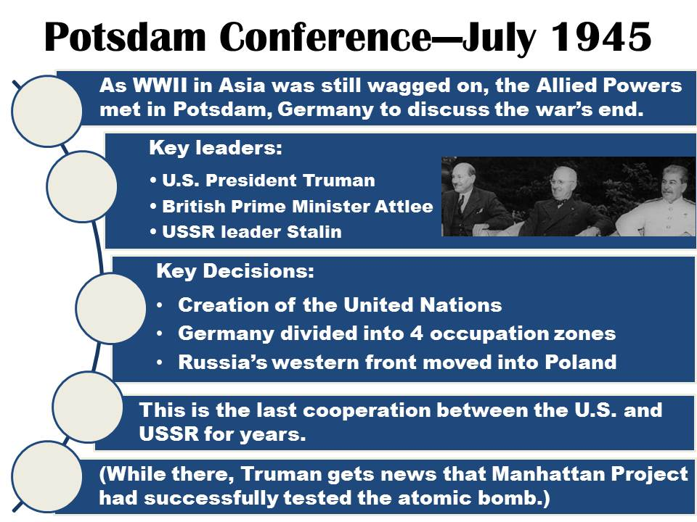Potsdam Conference

1. Look back in your notes from WWII. Compare the leaders that were present at the Yalta Conference in February 1945 with Potsdam in July 1945.

Yalta leaders:

New leaders at Potsdam:

How you think this change might have influenced the discussions?

1. 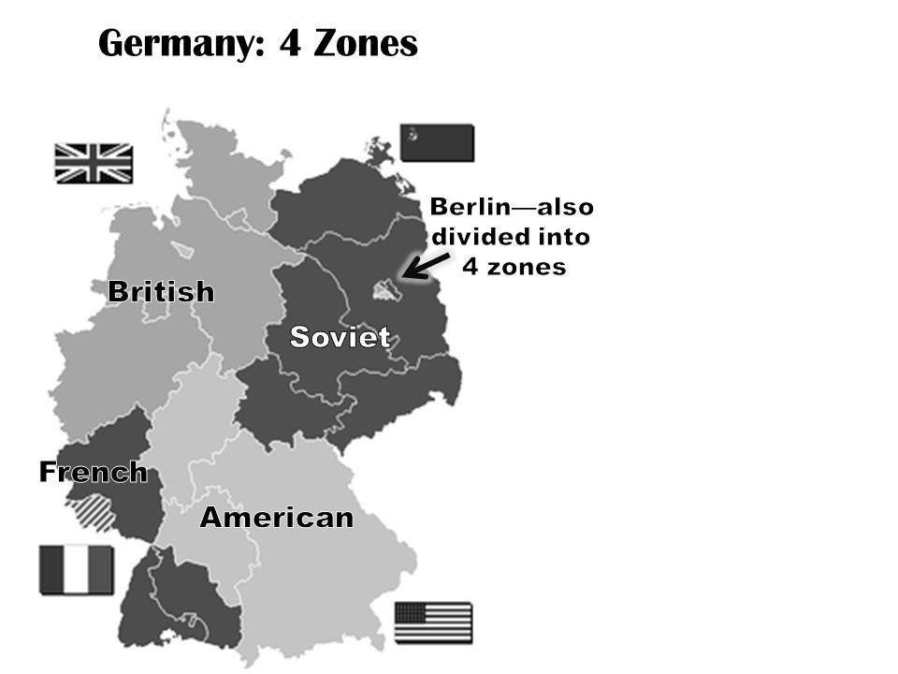Which of the key decisions do you feel is the most significant? Why?
2. Why do you think it might be significant that Truman learned about the atomic bomb test while at the conference?

Germany Zone Map

1. Why do you think they divided Berlin into 4 zones?

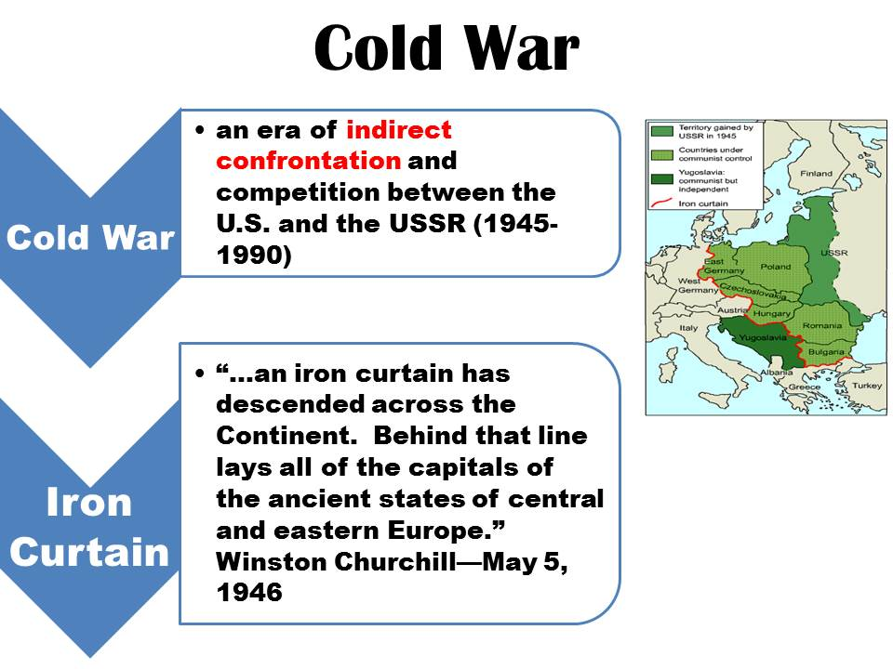

How do you think the Soviet’s felt about this?

1. Why do you suppose the French zone is so small?

Cold War Chart

1. Read the definition of the Cold War. What does it mean that it is “indirect confrontation” between the U.S. and USSR?

Give an example of a Cold War ”indirect confrontation”.

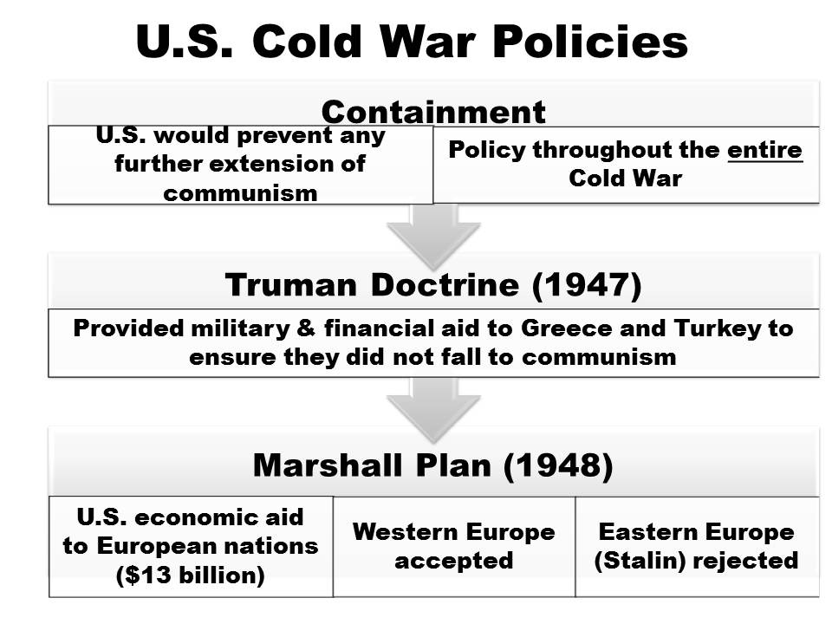

1. What do you think the “iron curtain” was that Churchill was referring too?

U.S. Cold War Policies

1. Explain the American policy of containment.
2. 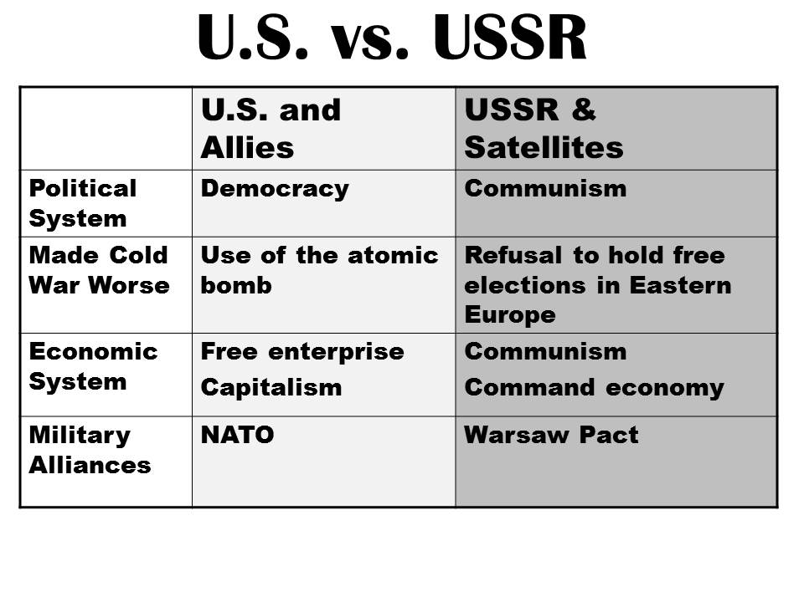The Truman Doctrine was created to help _______________ and _________________________. How does the Truman Doctrine tie to the policy of containment?
3. Why do you think the U.S. developed the Marshall Plan?
4. Why do you think the Eastern European nations reject the aid?

U.S. vs. USSR Chart

1. Why do you suppose the use of the atomic bomb made the Cold War worse?

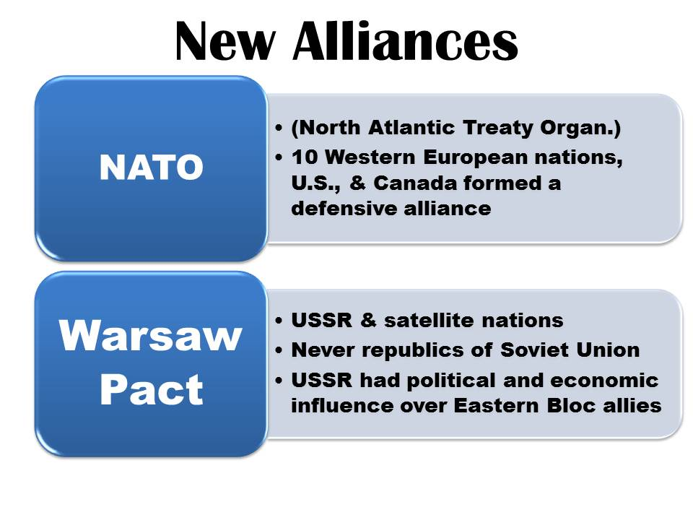

1. Why do you suppose the Soviet’s wouldn’t allow free elections in Eastern Europe?

New Alliances

1. NATO stands for: _________________________________
2. What does the term satellite nation mean? (use your phone to look it up if you are not sure)
3. How do you think NATO and the Warsaw Pact were different? (ask me if unsure)

Notes from the PowerPoint…

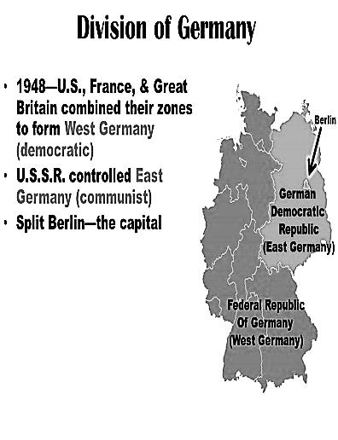

Division of Germany

Berlin Airlift