Hoover v. Roosevelt
 | Herbert Hoover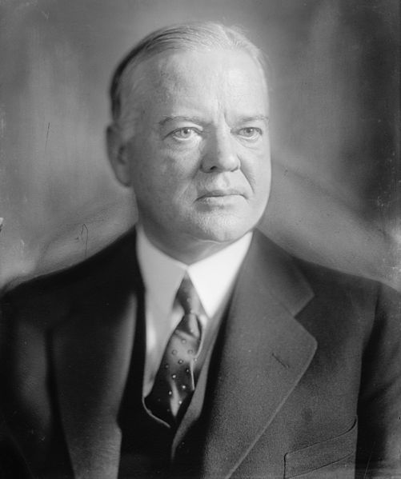 | Franklin D. Roosevelt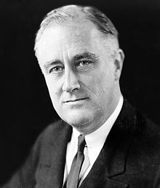
Response to Great Depression (government’s involvement in the economy)

Presidential Speeches
What phrases stand out in this speech? Why?
Does the speech specifically address the problems faced by Americans? If yes, provide an example.

Imagine that you are someone who has been unemployed for two years. Does either speech give you hope for your future - explain.
Based on these speeches, which of these men would you vote for? Explain.

