Start of WWI Map

Use the map on page 581.

Identify and label the following nations:
Ireland Great Britain France Italy Russia
Spain Portugal Germany Serbia Switzerland
Greece Bulgaria Ottoman Empire Sweden Norway

Identify and label the following bodies of water—color them blue with colored pencil!!
Atlantic Ocean North Sea Mediterranean Sea

Create a key and color code: (pick a different color for each)
Allied Powers Central Powers Neutral countries

Start of WWI Map

Use the map on page 581.

Identify and label the following nations:
Ireland Great Britain France Italy Russia
Spain Portugal Germany Serbia Switzerland
Greece Bulgaria Ottoman Empire Sweden Norway

Identify and label the following bodies of water—color them blue with colored pencil!!
Atlantic Ocean North Sea Mediterranean Sea

Create a key and color code: (pick a different color for each)
Allied Powers Central Powers Neutral countries

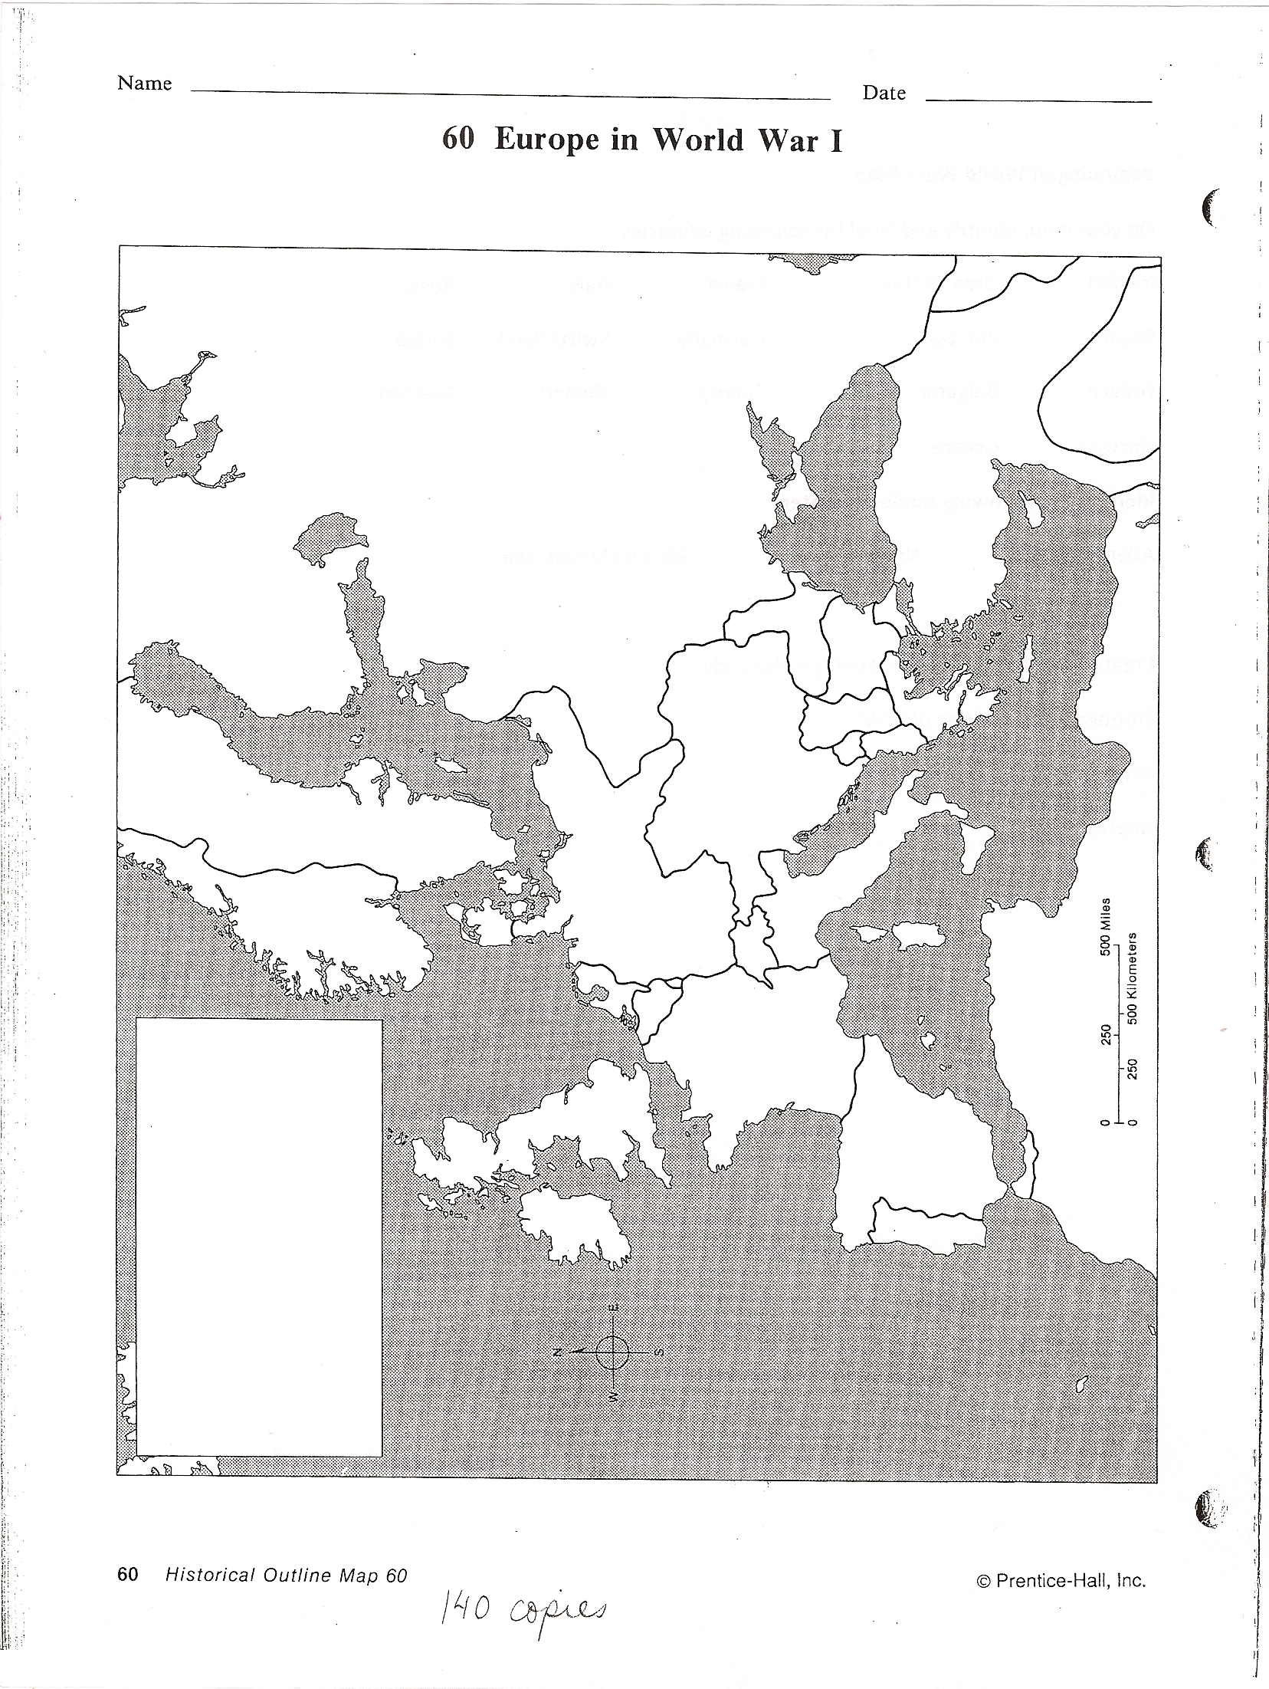
Name ___________________
Start of WWI Map

Name ___________________
Start of WWI Map

