WWI Begins Activity
U.S. on the Eve of WWI
When Woodrow Wilson took over the White House in March 1913, he promised a less expansionist approach to American foreign policy than Theodore Roosevelt and William Howard Taft had pursued. Wilson did share the commonly held view that American values were superior to those of the rest of the world, that democracy was the best system to promote peace and stability, and that the United States should continue to actively pursue economic markets abroad. But he proposed an idealistic foreign policy based on morality, rather than American self-interest, and felt that American interference in another nation’s affairs should occur only when the circumstances rose to the level of a moral imperative.
U.S. on the Eve of WWI
- What did President Wilson promise to do when he got elected?

- How did he feel about American values?

- What was Wilson’s view on foreign policy?

Do you agree with Wilson’s view? Explain.

Dance of Alliances Chart
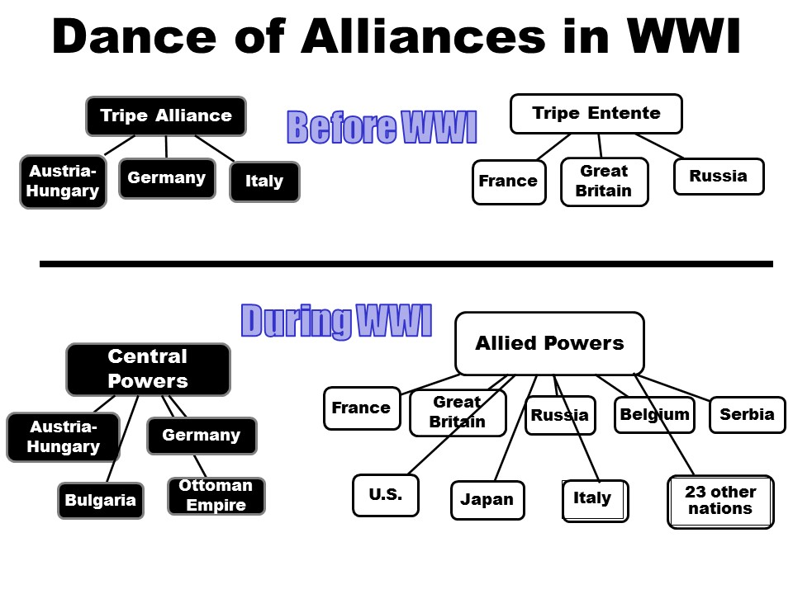
- Look at the alliances that formed before WWI. Which one do you think might be more powerful?

Why? (ask me if you need help)

- Before WWI began, some historians at the time said that this perfect balance of power would prevent a major war from ever beginning. Why do you think they were wrong?

- Compare the alliances before WWI and during. Which nation switched sides?

- What is surprising about the alliances during WWI?
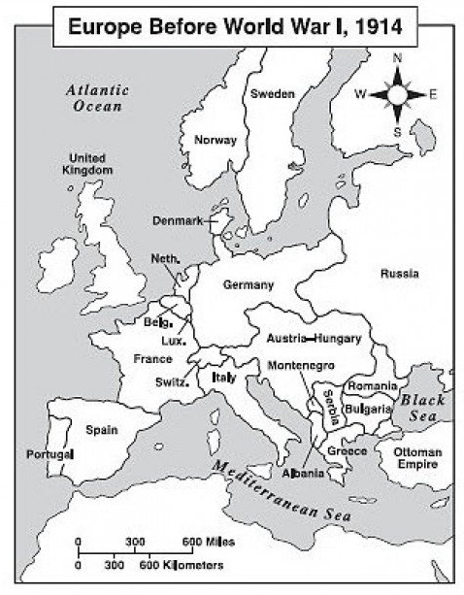

Map of Europe before WWI
- Get 2 colored pencils. Color the nations in the Triple Alliance one color and the Triple Entente another color.
- What do you notice about the location of the Triple Alliance?

- Look at Serbia and Austria-Hungary. Those two nations both claim rights to the regions called Bosnia and Herzegovina.
In 1908, Austria annexed, or took over, Bosnia and Herzegovina. These were areas with large Slavic populations. Serbian leaders, who had sought to rule these provinces, were outraged. In the years that followed, tensions between Serbia and Austria steadily rose. The Serbs continually vowed to take these regions away from Austria.

How might this cause tension in Europe?

Immediate Cause of WWI
Immediate Cause of WWI
Serbia and Austria-Hungary continued to struggle over their claims to Bosnia and Herzegovina. Into this poisoned atmosphere of mutual dislike and mistrust stepped the heir to the Austro-Hungarian throne, Archduke Franz Ferdinand, and his wife, Sophie. On June 28, 1914, the couple paid a state visit to Sarajevo, the capital of Bosnia. It would be their last. The royal pair was shot at point-blank range as they rode through the streets of Sarajevo in an open car. The killer was a Serbian and member of the Black Hand. The Black Hand was a secret society committed to ridding Bosnia of Austrian rule.
Because the assassin was a Serbian, Austria decided to use the murders as an excuse to punish Serbia. On July 23, Austria presented Serbia with an ultimatum containing numerous demands. Serbia knew that refusing the ultimatum would lead to war against the more powerful Austria. Therefore, Serbian leaders agreed to most of Austria’s demands. They offered to have several others settled by an international conference.
Austria, however, was in no mood to negotiate. The nation’s leaders, it seemed, had already settled on war. On July 28, Austria rejected Serbia’s offer and declared war. That same day, Russia, an ally of Serbia with its largely Slavic population, took action. Russian leaders ordered the mobilization of troops toward the Austrian border.
In response to Austria’s declaration of war, Russia, Serbia’s ally, began moving its army toward the Russian-Austrian border. Expecting Germany to join Austria, Russia also mobilized along the German border. To Germany, Russia’s mobilization amounted to a declaration of war. On August 1, the German government declared war on Russia.
Russia looked to its ally France for help. Germany, however, did not even wait for France to react. Two days after declaring war on Russia, Germany also declared war on France. Germany mores toward France by invading neutral Belgium. Soon afterward, Great Britain declared war on Germany.

- Go back to the alliances before WWI chart. How do you think those alliances impacted the beginning of WWI?

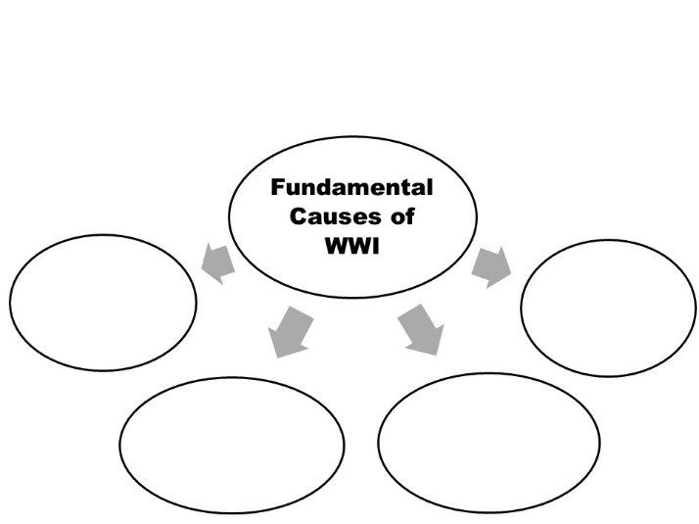
- Do you think that WWI could have been avoided? Explain.

