Civil War Map

Use the map on the projector (or on my website if you are completing it from home).

- Title the map: Civil War

- Label EVERY STATE AND TERRITORY on the map!!! (you can abbreviate)

- Color the Confederate States RED with colored pencils only.

- Color the United States BLUE with colored pencils only. (including the border states)

- Color the territories YELLOW with colored pencils only.

- Make a key as seen on the map.

Name __________________________________
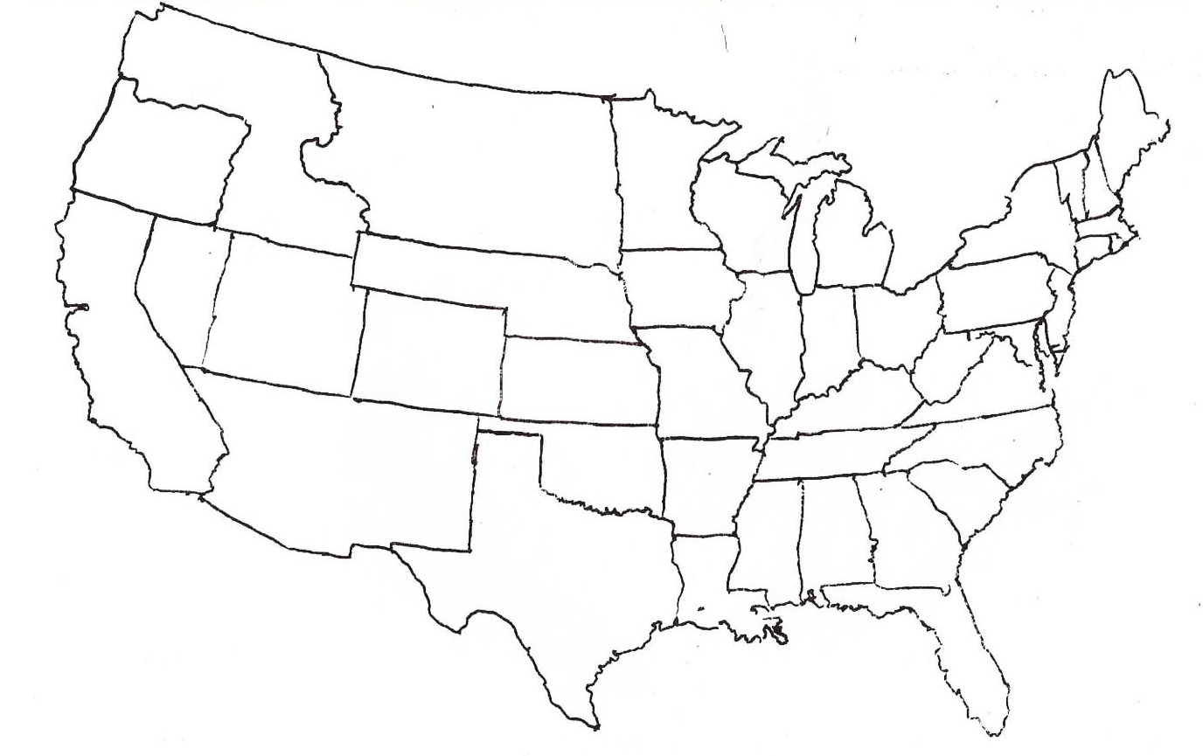
Title: _________________________________________
Key:

