Name _________________________________________________
Mongol Empire Map Activity
Use the map on page 372 of your textbook to complete this activity.
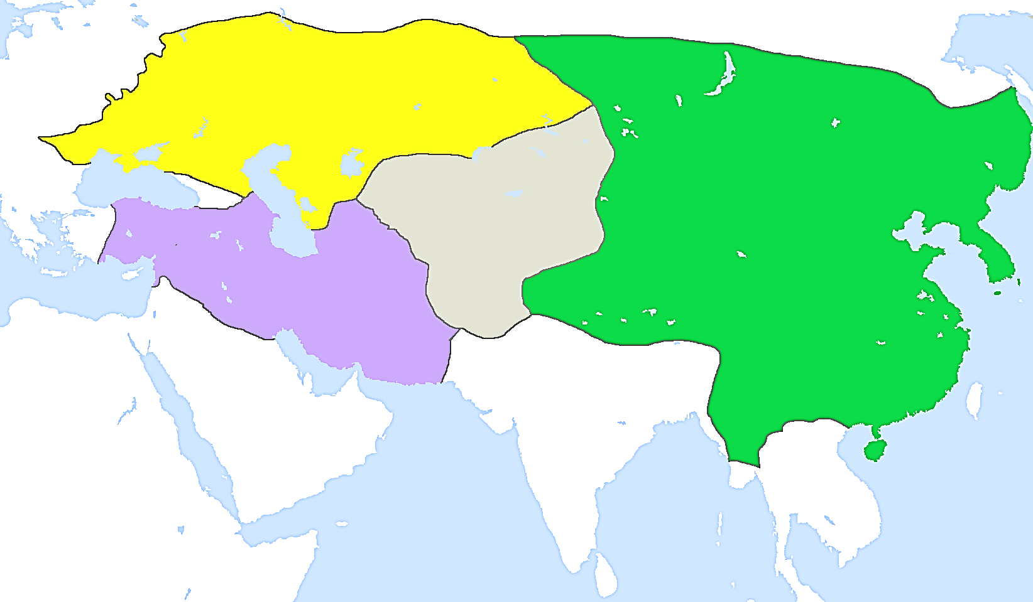
- Color code each khanate a different color and label each of the following:
Golden Horde Khanate Il-Khan Khanate
Chaghatai Khanate Great Khanate (called Khanate of the Great Khan)

- Label the following cities:
Kiev Moscow Baghdad Hangzhou

- Label the following bodies of water:
Mediterranean Sea Black Sea Caspian Sea Arabian Sea

- Label the following countries NOT controlled by the Mongols. (see page numbers)
Hungary (405) Poland (405) Sultanate of Delhi (369)

- Name three modern countries that lie in regions of the Khanates.
Golden Horde
Il-Khanate
Chaghatai Khanate
Great Khanate

- Which region did the Mongols unsuccessfully attempt to invade by sea? (You should know this from your reading)

- In what ways did Mongol empires and policies facilitate trade, travel, and communication throughout Eurasia?

