Name_________________________________________
Cold War Mapping Activity

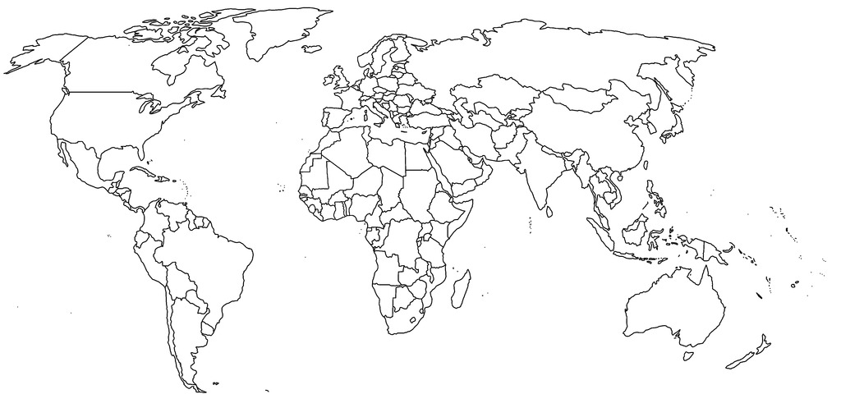
Key:

NATO
Warsaw Pact
Non-Aligned
Cold War Timeline
Put the key events from the readings in the correct decade (see the dates on the readings and INCLUDE them.)
Decade | Date | Event (name of the event is all that is needed)
1940s

1950s

1960s

1970s

1980s

1990s

